Optimist Coaches Seminar June 7 and 8 at Fishing Bay
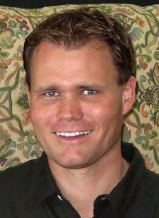
Kenneth Andreasen, U. S. Optimist Dinghy Association Director and Coach of the U. S. National Optimist Team, will give a two-day OPTIMIST COACHES SEMINAR at Fishing Bay on June 7 and 8.

Kenneth travels with the US Optimist team when they compete in international events.

Coaches, instructors, CIT’s and parents who volunteer with the racing team will want to learn all the latest tips for rigging Optis for speed, boathandling techniques, and on the water drills and games. Kenneth and his team of national and regional coaches are experts at developing amazing skills in young Optimist sailors. His coaching produces Optimist sailors who love sailing, have superb boathandling skills, and approach a racecourse with strategy and confidence that many adults envy.

Kenneth is anxious to share his coaching expertise with us, and is excited to be making his first visit to our area.

Cost for the program is only $75. If you are a coach, adult instructor or CIT for junior week, the club will cover your tuition.

Enroll by emailing ruthannaj@juno.com by May 20.

