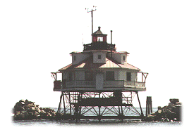

12th Annual
Stingray Point Regatta
For the Brent Halsey Jr. Memorial Trophy
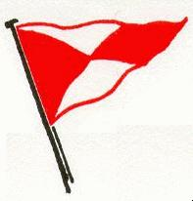
Fishing Bay Yacht Club
Deltaville, Virginia

Saturday, September 2, 2006 Sunday, September 3, 2006

Starts will be offered for:

PHRF A/B/C Spin MORC PHRF Non-Spin
If sufficient yachts are registered, One-Design classes may be added.

FEES: $100 per boat, $90 for US Sailing members, received no later than Friday, August 25, 2006 by 1800. Late Fee of $30 will be assessed for entries received after August 25th. Make checks payable to FBYC. Entry fee includes Friday welcome reception, continental breakfast Saturday and live music Saturday night with the Bopcats.

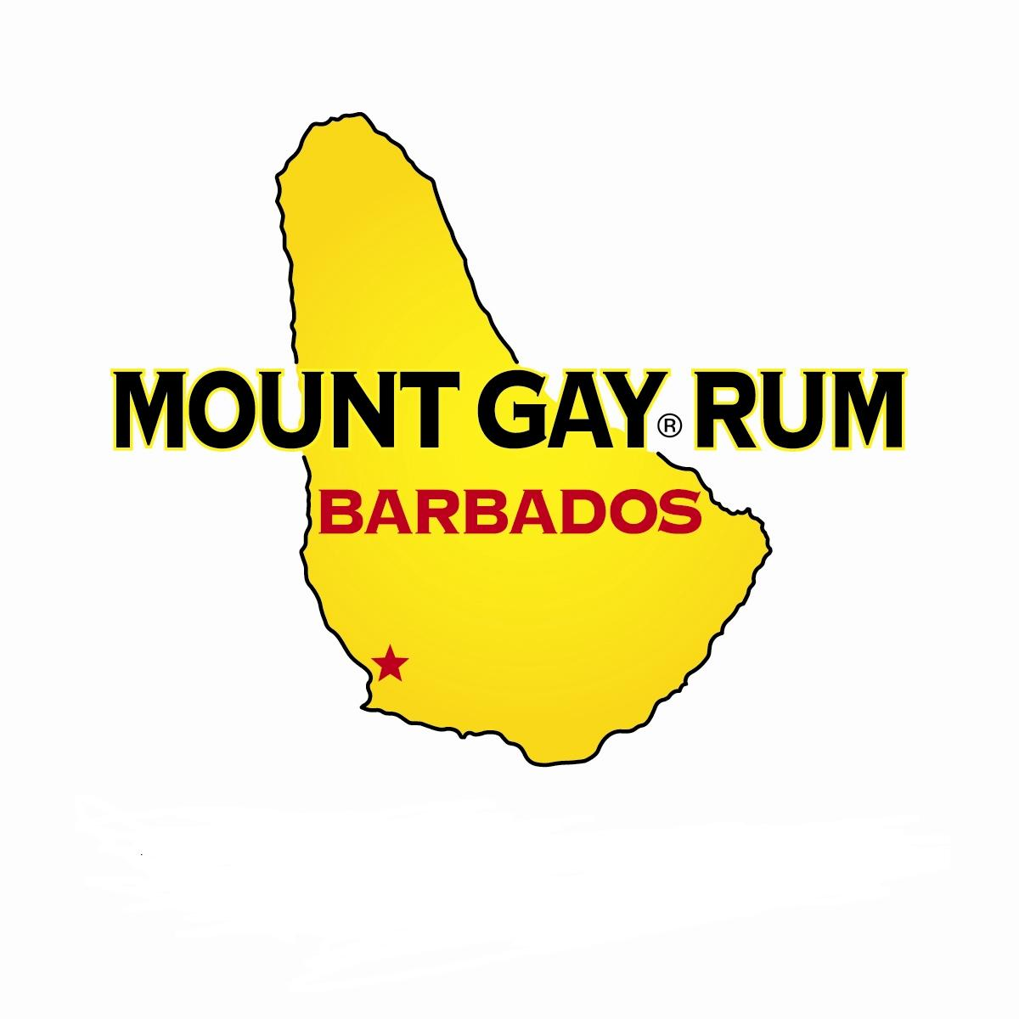
TWO DAYS OF GREAT RACING, PLUS:
Hospitality tents Saturday and Sunday featuring Mount Gay Rum
Catered Dinner Saturday Night
Breakfast Buffet Sunday Morning
Mount Gay Regatta Gear
Come join the premier regatta on the middle Chesapeake Bay!

For More Information and to register on line
Check Out www.fbyc.net

