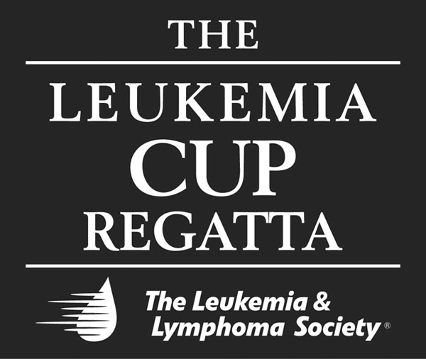

The 9th ANNUAL
LEUKEMIA CUP REGATTA

SOUTHERN CHESAPEAKE SAILING SERIES

An event combining the challenges and fun of sailing while raising funds to support The Leukemia & Lymphoma Society.

RAISE A SAIL. SAVE A LIFE.

About The Leukemia & Lymphoma Society

The Leukemia & Lymphoma Society is the world’s largest voluntary health organization dedicated to funding blood cancer research and providing education and patient services. We offer a variety of programs and services in support of our mission: Cure leukemia, lymphoma, Hodgkin’s disease and myeloma, and improve the quality of life of patients and their families. The Society is a nonprofit organization that relies on the generosity of individual and corporate contributions to advance its mission.

Facts 2005-2006

- It is estimated that 747,465 Americans are living with blood cancers. Leukemia, Hodgkin and non-Hodgkin lymphoma and myeloma are cancers that originate in the bone marrow or lymphatic tissues. Approximately every five minutes, someone is diagnosed. Every 10 minutes, another child or adult is expected to die from leukemia, lymphoma or myeloma. This statistic represents 149 people each day, or six people every hour. Leukemias are the leading fatal cancers in young men and women under age 20.

Research

- Since the first funding in 1954, the Society has awarded $411 million in research grants. Now about $50 million annually, the Society’s grant programs are among the most prestigious in the fields of hematology and oncology.

Patient Services

- The Society has a network of 64 chapters throughout the United States, with additional branches in Canada, that conducts life-enhancing patient services, including support groups, peer counseling and patient financial aid.

Advocacy

- Since 1994, The Leukemia & Lymphoma Society’s advocacy program has been a strong voice in Washington, DC, representing to policy makers at all levels of government the healthcare quality concerns and medical research interests of patients and their families

Event Overview

WHAT:
Sail boat races in which volunteers sail, crew or cheer while raising funds for The Leukemia & Lymphoma Society. The Leukemia Cup Regatta is an established, successful annual event in its 9th year with local and national celebrity participation and sponsors. It isa highly-visible, high-profile event which is growing nationwide. The regatta is hosted by Stingray Point Marina in Deltaville, Virginia and coordinated by a well established and knowledgeable planning committee

WHO:
Sail boat enthusiasts or those who like to watch from shore. Anyone with an interest inregattas and a passion about raising funds to find cures for cancer is welcome. Participants return year after year from communities all along the Chesapeake Bay.

WHY:
To benefit The Leukemia & Lymphoma Society's efforts to fund research to find cures for leukemia, lymphoma, Hodgkin’s disease and myeloma, and to provide education and patient services for patients and families combating these diseases.

MISSION STATEMENT:
Cure leukemia, lymphoma, Hodgkin’s disease and myeloma and improve the quality of life of patients and their families.

NATIONAL CHAIR:
Gary Jobson

LOCAL CO-CHAIRS:
Judy Buis
Carolyn Norton Schmalenberger

NATIONAL SPONSORS:
John Mecray, Noted Marine Artist

Mount Gay Rum
North Sails
Sailing World
West Marine

DATES & DESRIPTIONS OF THE 2007
SOUTHERN CHESAPEAKE
LEUKEMIA CUP REGATTA SERIES

Kickoff with Gary Jobson: March 16th, 2007
The Leukemia & Lymphoma Society along with Fishing Bay Yacht Club kickoff the series with presenter Gary Jobson at the University of Richmond, Moot Courtroom. Gary is a world class sailor, television commentator and author as well as the National Chair for the Leukemia Cup Regatta. The event is open to the public, tickets are $20.00 (half price for students). Visit www.fbyc.net to register.

Junior Challenge: May 12, 2007
Hosted again by Christchurch School, this junior event targets young sailing enthusiasts. Schools from all across Virginia will be participating in this exciting fund raising event. Thanks to the tremendous success of the 2006, we look forward to another exciting event in 2007!

Kayak Tour: May 12, 2007
Organized by Bay Trails outfitters in Matthews, this is an event for all ages that have a passion for kayaking. Tour the Chesapeake Bay area while raising funds to support the Society. Refreshments, incentives and an informal reception are all included.

Arts at FBYC: June 8, 2007
Enjoy an evening of music and art to benefit The Leukemia & Lymphoma Society. This casual gathering is the perfect time to purchase some beautiful new artwork, and mingle with other sailors and volunteers! Join us at Fishing Bay Yacht Club in Deltaville.

Sail-A-Thon: June 21, 2007
Fishing Bay Yacht Club will again host the Junior Sail-A-Thon in 2007. The event is a sailing fundraiser for kids to collect pledges and donations for the number of laps they can sail around the course in the allotted timeframe. This is not a race. Trophies will be given for the top fundraisers. In addition, each participant will receive a goodie bag and an official Leukemia Cup Regatta Tee Shirt. We hope that all parents and kids will participate in this family fundraising event.

Regatta Race weekend: July 6-8, 2007
Come ready to bid, as this silent and newly-added live auction hosts wonderful items ranging from packages for boating enthusiasts, beautiful artwork, wood carvings, and other art exclusive to the Chesapeake area. Music, crab cakes and more make the evening one to enjoy! Held at Stingray Point Marina.

Regatta Race Days: Saturday & Sunday, July 7-8, 2007
Regatta Race Days have arrived!



27 W. Queens Way, Suite 301
Hampton, VA 23669
757-723-2676 1-800-866-4483
Fax 757-723-4056

DONATION OF GOODS OR SERVICES

- COMPANY: ___________________________________________

- ADDRESS: _____________________________________________

- CITY: _________________________________________________

- PHONE: _________________________________________________

Description of donated Goods or Services:

Value of Donation:

- Item needs to be picked up. Please have a volunteer or employee, contact me.
- I will deliver the item to the Leukemia & Lymphoma Society office.
- I will mail the item to the Leukemia & Lymphoma Society
- Other___________________________________

The Leukemia & Lymphoma Society Use Only:

The Leukemia Cup Regatta

THANK YOU FOR YOUR SUPPORT OF THE LEUKEMIA & LYMPHOMA SOCIETY

Please retain a copy of this form for your records

CONTACT INFORMATION

Thank you for the opportunity to share our excitement about The 2007 Leukemia Cup Regatta!

For more information please contact:

Sue Willis
Campaign Manager
The Leukemia & Lymphoma Society, Virginia Chapter
27 W. Queens Way, Suite 301
Hampton, VA 23669
(757) 723-2676 or 1-800-866-4483
Fax: (757) 723-4056
Email: sue.willis@LLS.org

The Leukemia & Lymphoma Society would value and appreciate your partnership.

