2006 Leukemia Cruising Class & Classic Boat Class
Sailing Instructions July 7-8, 2007
General Information
1. The 9th ANNUAL LEUKEMIA CUP REGATTA SOUTHERN CHESAPEAKE SAILING SERIES is hosted by Fishing Bay Yacht Club, York River Yacht Club and Stingray Harbor Marina. This regatta will consist of up to 2 races on each day to be sailed by the Leukemia Cruising and Classic classes on the west course. The races and associated activities are to benefit the Leukemia & Lymphoma Society of America.

2. Registration will be Friday night, July 6th, from 7 to 9pm at the Crabcakes and Silent Auction Event, Stingray Point Marina, and Saturday, July 7th, from 8 to 9am at the south clubhouse at Fishing Bay Yacht Club. The grand gala will be at Stingray Point Marina Saturday evening at 5pm. The Race Awards ceremony will be held after the races on Sunday at Fishing Bay Yacht Club.

3. The legal drinking age in Virginia is 21. Minors will not be served and proof of age will be required. Intoxication or discourteous behavior will be grounds for expulsion from the events. Boat captains and owners will be responsible for the actions of their crew. A BOAT IS SUBJECT TO IMMEDIATE DISQUALIFICATION IF ANY OF ITS UNDER-AGE CREW IS FOUND TO BE ILLEGALLY CONSUMING ALCOHOL.

4. Parking at Fishing Bay Yacht Club is limited to the lot in front of the new clubhouse, the lot on the Jackson Creek side, and the grass field to the east on the Jackson Creek side. No cars may be parked on either side of the road, which must remain open for emergency vehicles.

SCHEDULE OF EVENTS
Friday, July 6
1900-2100 Crabcake dinner, music, Pre-Registration, & Silent Auction at Stingray Point Marina
Saturday, July 7
0800 Race registration and box lunches for sale at FBYC
0800-0900 Continental breakfast at FBYC
0900 Skippers meeting at FBYC flagpole near Jackson Creek
1045 Warning signal for first race (note location below)
ASAP Warning signal for second race (if time and weather permit)
1700-2200 Grand Gala at Stingray Point Marina
Boats may layover at Fishing Bay Yacht Club in Fishing Bay or Jackson Creek.
Sunday, July 8
0800-0900 Breakfast @ FBYC ---No Skippers Meeting
0945 Warning Signal as described for Saturday’s races.
ASAP Warning signal for second race (if time and weather permit)

ASAP Sailing Awards at FBYC after the finish of Sunday Races.

- RULES
This event shall be governed by the International Sailing Federation Racing Rules of Sailing, as adopted by the United States Sailing Association, and by these Sailing Instructions. Eligible boats may enter by submitting a completed Leukemia Cup Registration Form 2007 by 0900 Saturday, July 7, 2006.

- RATINGS
Boats should have a valid PHRF certificate on file. Boats without a certificate shall be assigned a rating by the Race Committee.

- SAIL NUMBERS / IDENTIFICATION
All entrants must clearly identify the boat and its class. The Leukemia Cruising Class flag shall be a green ribbon. The Classic Boat flag shall be an orange ribbon. Class flags will be distributed during registration, and must be flown from the boat’s backstay during the race. Skippers in the Classic Division, please make sure your boat has been placed in the proper subdivision (full or fin).

- RACING AREA
The racing area shall be as indicated on the accompanying chart and in the table below. The start/finish line shall be between an orange flag on the committee boat and an orange inflatable mark.
 | Mark | Lat (N) | Long (W) | Leg | Course (M) | Nm
START | Committee Boat | 37° 32.345’ | 76° 17.677’
First Mark | Orange Cylinder | 37° 31.800’ | 76° 16.700’ | 1 | 125° | 1.10
Second Mark | Orange Cylinder | 37° 32.705’ | 76° 16.559’ | 2 | 007° | 1.10
FINISH | Committee Boat | 37° 32.345’ | 76° 17.677’ | 3 | 248° | 1.10

- COMMITTEE BOAT DESCRIPTION
The Race Committee Boat will be a 50’ sailboat named Anatalya anchored at the designated location. She will be flying a large blue “RC” flag and will be stationed at one end of the start/finish line.

- SAFETY
All boats participating in the Leukemia Cruising and Classic Boat Classes should monitor the race committee boat working channel, VHF Channel 72, before and during the races. A boat retiring from the race shall notify the Race Committee as soon as possible. Note also that US Sailing prescribes that every boat shall carry life-saving equipment conforming to government regulations.

- STARTING SEQUENCE
Two races will be run each day if time and weather permit. There will be two class starts, with flag and sound signals as described below. All signals will be made from the Race Committee Boat. Note that the flag, not the sound, is the official signal! Please do not communicate with the Race Committee boat once the start sequence has begun and during the sequence unless an emergency.
8.1 Races will be started in accordance with Racing Rules of Sailing rule 26. If you are not familiar with RRS 26, it is reproduced at the end of these instructions and here is how it works:
Your class flag will be hoisted 5 minutes before your start (the warning signal) and will be lowered at your start. In-between, code flag “P” will be raised as your Preparatory signal four minutes before your start, and it will be lowered one minute before your start.
For example, when the Green flag is raised it is five minutes from the start of the Cruising Class, and five minutes later the Green flag will be lowered to signal the start. In-between, code flag “P” will be raised and lowered at four minutes and one minute, respectively. All of these raisings and lowerings will be accompanied by a sound signal as described in RRS 26 reproduced at the end of these sailing instructions.

8.2 An addendum will be available at registration detailing Division and any subdivision fleet assignments. Committee Boat class flags for the starting sequence will be a larger version of those to be flown from each boat while racing.

8.3 The starting line will be between a staff displaying an orange flag on the Committee Boat at the starboard end and the starting mark (an inflatable buoy) at the port end.

8.4 Boats whose Warning Signal has not been made shall keep clear of the starting area and of all boats whose Warning Signal has been made.

First Race
Warning Signal for the first Class on Saturday will be given at 1045. Warning Signal for the first Class on Sunday will be given at 0945.
Second Race (time and weather permitting)
If a second race will be held the Race Committee will fly code flag “R” at the end of the first race. If code flag “R” is flying, all boats should stay in the vicinity of the Race Committee starting boat, while making sure not to interfere with competitors still racing. The Warning Signal for the second race will be given as soon as possible after the end of the first race. A series of horn blasts will be used to indicate that the Warning Signal is imminent.
Other Signals
The race committee shall display the ‘X’ flag (individual recall) and give horn signals if one or more boats are ‘over-early’ at the start, in which case those boats must return to the pre-start side of the starting line and re-start. The race committee will attempt to broadcast boat names or sail numbers on VHF channel 72 but it is the skipper’s responsibility to observe all signals and make a proper start.
If code flag ‘AP’ flag is used to postpone the start, lowering of the ‘AP’ flag with one long horn blast shall indicate one minute to the warning signal (10 minutes to Multihull start).

- FINISHING
Each boat finishing will receive a sound signal as she crosses the line. Upon finishing, all boats shall clear the finish line and then pass close to the committee boat on the side away from the finish line. Hail the committee boat with your boat’s name until acknowledged to ensure that you are properly identified and scored. If the second race is to be run, remain in the vicinity of the committee boat after completing the first race but stay clear of the finish line.

- SHORTENED COURSE / TIME LIMIT / ABANDONMENT / RETIREMENT
Watch for the shortened course signal, Code flag “S”, on the committee boat if the committee boat has moved to either the first mark or the second mark. The finish line will be between the committee boat and the mark.
The finish of one boat of a class within two hours of her start shall make the race valid. All boats not finishing within three hours of their start shall be scored one more point that the last boat finishing within three hours.
If the race must be abandoned for any reason, verbal notice of abandonment shall be given on VHF channel 72.
A boat that retires from a race shall notify the race committee as soon as possible. VHF Channel 72 may be used for this notification.

- PENALTIES
A boat infringing a rule of RRS Part 2 may take a penalty in accordance with RRS 44.2, by doing a 720-Degree penalty turn, when well clear of other boats but before she finishes.

- PROTESTS
RRS 61.1(a) is modified to require that notice of intent to protest and the name or sail number of the protested boat be given to the Race Committee immediately after finishing by hail acknowledged by the Race Committee.
Written protests must be filed with the Race Committee within one hour of the Race Committee boat being docked. Representatives of boats who are parties to a hearing shall remain on call in the vicinity of the FBYC Clubhouse (protest room).

- EQUIPMENT
All equipment and minimum standards required by the U.S. Coast Guard, the RRS, and Division/Class Rules, shall be aboard and readily available.

- AWARDS
Class awards will be given for 1 st, 2 nd, and 3rd places.

Thank you for coming to this year’s event and all of us hope you experience great times and great sailing.

Good Luck!

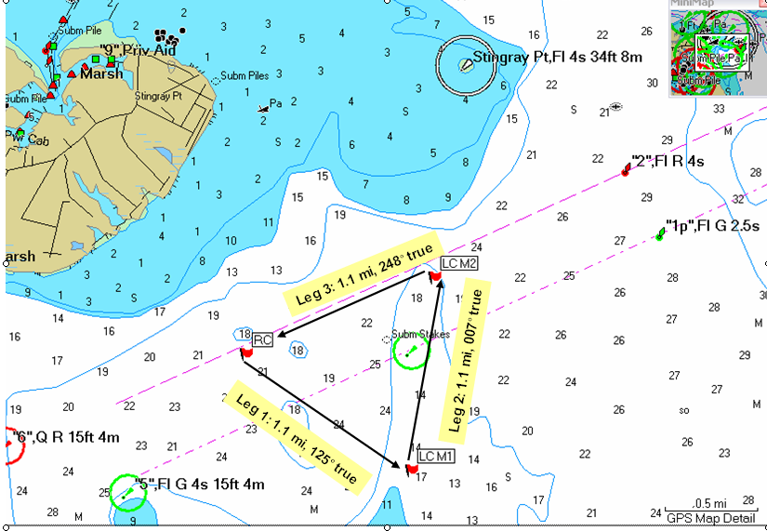
NOT TO BE USED FOR NAVIGATION
Racing Rules of Sailing information:
