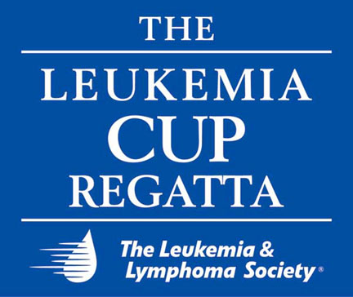

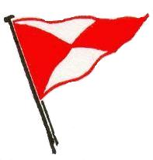

FBYC and the Leukemia & Lymphoma Society
Present Tucker Thompson on February 20

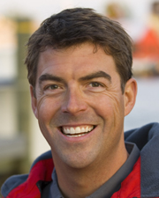
The Leukemia & Lymphoma Society and the Fishing Bay Yacht Club Winter Program Series will again team up to kick-off the 11th Southern Chesapeake Leukemia Cup season with an appearance in Richmond by Tucker Thompson, accomplished Annapolis sailor, internet media entrepreneur, and partner in T2 Productions that produces videos of popular sailing events and related topics.

Thompson is well known for his work with t2p.tv, a full service video production company that has been operating since 2000. t2p.tv has become the complete source for on air coverage of sailing. From major regattas throughout the US and Caribbean to sailing destinations, to the sailors, the boats and the sport, t2p.tv covers it all and provides the on-demand online broadcasts.

His exciting presentation will be held at 7 pm, February 20, at Dominion Resources Auditorium in Innsbrook Office Park, 5000 Dominion Blvd, Glen Allen, Virginia. Admission: $20 advanced tickets, $25 at the door, and $15 students. There will be a cash bar and light Hors D'eouvres. The public is invited to attend and all proceeds after expenses will benefit the Leukemia & Lymphoma Society. Advance registration is available on line at www.fbyc.net.

In other Leukemia Cup news, the 2009 event calendar is now complete. Again this summer the Auction and Gala will be held on the grounds of the Fishing Bay Yacht Club affirming a successful effort last year to consolidate these major activities at a single location with a nautical setting. This consolidation also benefited visiting yachts with more convenient access to evening events during Regatta weekend.

The full 2009 schedule is outlined below.

Junior Challenge at Christ Church School | May 2
Kayak Tour at Deltaville Maritime Museum | May 9
Art on Fishing Bay at Fishing Bay Yacht Club | June 5
Junior Sail-A-Thon at Fishing Bay Yacht Club | June 25
One-Design Challenge at Fishing Bay Yacht Club  Auction at Fishing Bay Yacht Club | July 5  July 10
The Regatta at Fishing Bay Yacht Club | July 10-12
Gala at Fishing Bay Yacht Club | July 11

The Regatta weekend July 10-12 will herald the beginning of the second decade of this signature Southern Bay event and will again be jam-packed with exciting races, fun, good food, entertainment, along with a continuation of the enormously popular auction on Friday evening. Leading up to the Regatta, sailors and their crews raise funds for the Society to compete for prizes and a “Fantasy Sail” with Gary Jobson, world class sailor, television commentator, and author.

The Regatta is being hosted again this year by the Fishing Bay Yacht Club and the Stingray Harbour Yacht Club, both located in Deltaville. Watch for more information on the Regatta and related Leukemia & Lymphoma Society in the months ahead. For more information on all Leukemia Cup events, please check out www.leukemiacup.org/va.

The Leukemia & Lymphoma Society(r), headquartered in White Plains, NY, with 68 chapters in the United States and Canada, is the world's largest voluntary health organization dedicated to funding blood cancer research and providing education and patient services. The LLS mission: Cure leukemia, lymphoma, Hodgkin's disease and myeloma, and improve the quality of life of patients and their families. Since its founding in 1949, LLS has invested more than $550 million in research specifically targeting leukemia, lymphoma and myeloma. Last year alone, LLS made 5.1 million contacts with patients, caregivers and healthcare professionals. For more information about blood cancer, visit www.LLS.org.
~(\,~

