GENERAL INFORMATION
 | 11th ANNUAL LEUKEMIA CUP REGATTA  SOUTHERN CHESAPEAKE SAILING SERIES  WEST COURSE SAILING INSTRUCTIONS  July 11 & 12, 2009

- The 11th ANNUAL LEUKEMIA CUP REGATTA SOUTHERN CHESAPEAKE SAILING SERIES is hosted by Fishing Bay Yacht Club, and Stingray Harbor Marina. This regatta will consist of up to two races each day to be sailed by the Leukemia (Cruising) and Classic classes on the WEST course (see sailing instructions below) and two or more races each day to be sailed by the PHRF classes on the EAST course. (sailing instructions distributed separately). The races and associated activities are to benefit the Leukemia & Lymphoma Society of America.
- Race headquarters and registration will be at the Fishing Bay Yacht Club clubhouse. There will be registration on Friday night at Fishing Bay Yacht Club. The grand gala will be at Fishing Bay Yacht Club Saturday evening at 5:30 pm. The sailing awards ceremony will be held after the races on Sunday at Fishing Bay Yacht Club.
- The legal drinking age in Virginia is 21. Minors will not be served and proof of age will be required. Intoxication or discourteous behavior will be grounds for expulsion from the events. Boat captains and owners will be responsible for the actions of their crew. A BOAT IS SUBJECT TO IMMEDIATE DISQUALIFICATION BY THE PROTEST COMMITTEE IF ANY UNDER-AGE CREW IS FOUND TO BE ILLEGALLY CONSUMING ALCOHOL.
- Parking at Fishing Bay Yacht Club is limited to the lot in front of the clubhouse, adjacent new property (unless ground is too soft), the lot on the Jackson Creek side, and the grass field to the east on the Jackson Creek side. No cars may be parked on either side of the road, which must remain open for emergency vehicles.

SCHEDULE – WEST COURSE
Leukemia Cruising and Classic Classes
 | FRIDAY JULY 10
1900-2100 | Crabcake dinner, music, Pre-Registration, & Silent Auction at Fishing Bay Yacht Club
 | SATURDAY JULY 11
0800-0900 | Breakfast and registration at FBYC clubhouse
0900 | Skippers Meeting at FBYC flagpole on Jackson Creek side
1045 | Warning signal for first race (note location below)  Warning signal for second race will be as soon as possible after the first race  Boats may layover at Fishing Bay Yacht Club in Fishing Bay or Jackson Creek.
1730-2200 | Gala and Fundraising awards at the Grand Gala at Fishing Bay Yacht Club
 | SUNDAY JULY 12
0800-0900 | Breakfast FBYC – No Skippers Meeting
0945 | Warning signal for first race.  Warning signal for second race will be as soon as possible after the first race
ASAP | Sailing Awards at FBYC after the finish of races on Sunday.

RULES

The regatta will be governed by the Racing Rules of Sailing (RRS).

ENTRIES

Eligible boats may be entered by completing a Leukemia Cup Registration form on the FBYC.net web site or in writing at registration on Friday night or Saturday morning (refer to the schedule).

Boats not having a current valid PHRF rating will be assigned a provisional rating which may not be appealed.

Boats entering the Classic Division, please make sure your boat has been placed in the proper subdivision (full or fin).

2.4 Boats will be sailed allowing only one (1) headsail downwind.

NOTICES TO COMPETITORS

Notices to competitors will be posted on the official regatta notice board located outside the lower level of the FBYC Clubhouse (know as Fannie’s House) on the Jackson Creek side.

A competitors’ (Skippers) meeting will be held at 0900 on the first day of a regatta.

CHANGES TO SAILING INSTRUCTIONS

Changes to the sailing instructions shall be numbered and posted by 0830 on their effective day, except that any change to the schedule of races shall be posted by 1800 on the preceding day.

SIGNALS MADE ASHORE

Signals made ashore will be displayed from “Mr. Roberts II,” the Race Committee boat at her berth on Jackson Creek.

When a change to the sailing instructions is posted, Code Flag “L” will be displayed from the committee boat.

When racing is postponed, code flag “AP” shall be displayed from the committee boat. Two horns will be sounded when it is raised and one when it is lowered. The warning signal will be made no earlier than 60 minutes from the lowering of “AP”.

SCHEDULE OF RACES

The scheduled time of the warning signal for the first race on Saturday is 1045.

The schedule time of the warning signal for the first race on Sunday is 0945.

Two races will be run each day (time and weather permitting).

On Sundays, no warning signal will be made after 1500.

CLASS FLAGS

Classes may be sub-divided or combined in order to improve the quality of racing. Such actions will be posted on the official notice board.

7.2 The Leukemia Cup class flags for the (Cruising), (Classic), and other sub-classes will be colored ribbons, and must be flown from the backstay of the boat while racing.

7.3 The class flags (ribbons) will be in the information package given out at registration.

7.4 Class Flags used to signal the start of each class shall be a flag of the same color as the issued class (ribbon) flag.

RACING AREAS
Racing will is shown on Attachment 1.

OFFICIAL BOATS

The Race Committee Boat will be anchored at the designated location shown in Attachment 1.

Other official boats will display the FBYC burgee. They will be identified at the Skippers Meeting.

MARKS

Start and finish will be the Committee Boat

The Committee Boat will be positioned at 37º32.345’ Lat and 76º17.677’ Long.

The rounding marks will be orange cylinders.

The First Mark, at the end of Leg 1, will be positioned at 37º31.800’ Lat and 76º16.700’ Long. The course from the start to the first mark will be 136ºM. The length of Leg 1 is .94 Nm.

The Second Mark, at the end of Leg 2, will be positioned at 37º32.705’ Lat and 76º16.559’ Long. The course from the first to the second mark will be 18ºM. The length of Leg 2 is .91 Nm.

The course to the finish line from the Second Mark, Leg 3, will be 259ºM. The length of Leg 3 is .95 Nm.

CHECK IN

Each boat shall sail by the race committee signal boat, hail her sail number and be acknowledged by the race committee with a return hail of her sail number. This shall be done before a boat starts the first race in which she competes each day.

THE START

Races will be started by using rule 26. Please refer to Attachment 2 for Rule 26 details.

The absence of a sound signal during the starting sequence shall be disregarded.

The starting line will be between a staff or halyard displaying an orange flag on the race committee signal boat and the course side of the pin end mark. The pin end mark will be an inflatable buoy.

Boats whose warning signal has not been made shall avoid the starting area.

A boat starting later than 10 minutes after her starting signal will be scored Did Not Start. This changes rule A4
ATTACHMENT 1 – RACING AREA
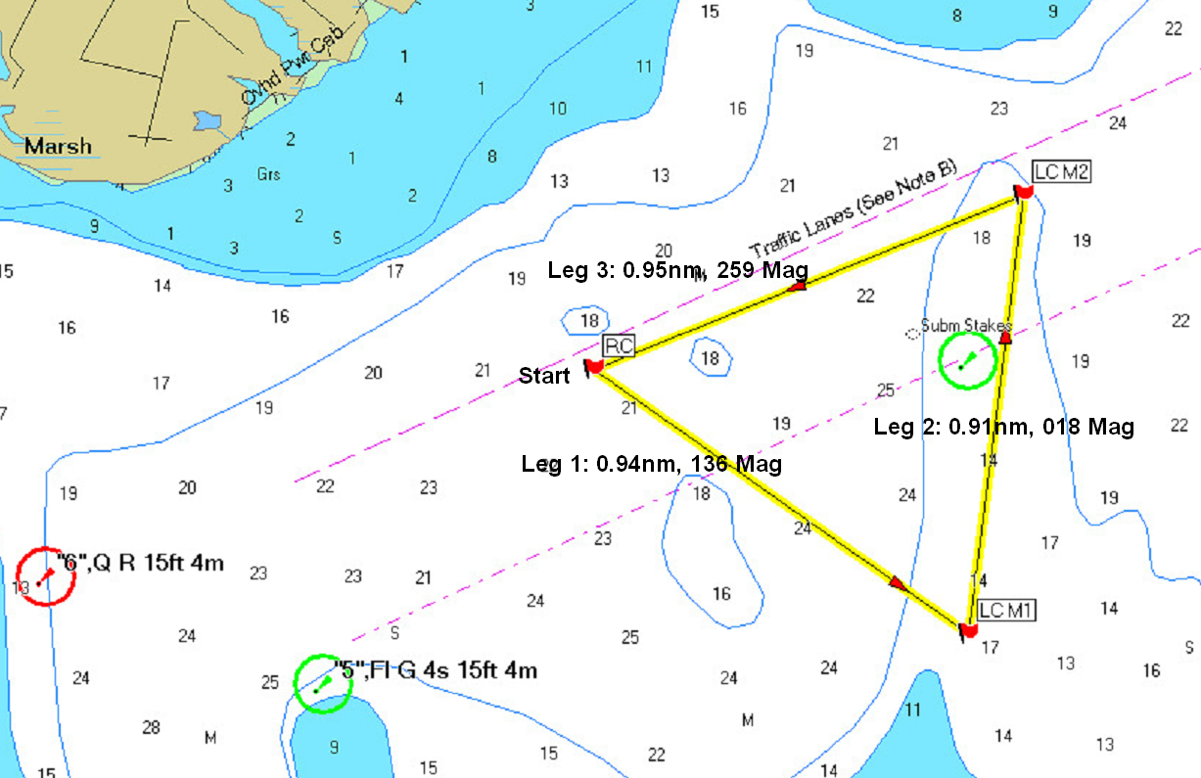

Second race of each day (time and weather permitting) shall be signaled from the committee boat by displaying the Second Substitute while boats are finishing the first race. The Warning signal will be given as soon as possible after the end of the first race. A series of horn blasts will be used to indicate that the Warning signal of race 2 is imminent.

THE FINISH

The finishing line will be between a staff or halyard displaying an orange flag on the race committee finish boat and an orange inflatable mark.

Each boat will receive a sound signal when the boat finishes. After finishing, each boat must keep clear of the racing area, including the finishing area.

SHORTEN COURSE
The race committee may shorten the course by moving to the First or Second mark and displaying the code flag “S” when anchored. The finish line will be between the mark and a staff or halyard displaying an orange flag on the race committee finish boat.

TIME LIMITS

Time limit is 2 hours for each class.

Boats that have not finished and are still racing three hours after their start will be scored as 'Time Limit Expired’ (TLE) and will be scored one more point than number of finishers, however no boat will receive a score worse than the number of points awarded a DNF. This changes rule 35 and Appendix A.

Boats that have not finished and are still racing but are substantially delaying the start of the second race of the day may be requested by the Race Committee to return to the starting area and accept a score of ‘Time Limit Expired’ (TLE). A boat complying with this request from the Race Committee shall be scored one more point than number of finishers, however no boat will receive a score worse than the number of points awarded a DNF. This changes rule 35 and Appendix A.

The race committee may abandon a race. Verbal notice of abandonment will be broadcast over VHF Channel 65. The race committee will also display the code flag “N” and possibly other signals as described in Rule “Race Signals”.

PROTESTS AND REQUESTS FOR REDRESS

A boat intending to protest another boat must notify the race committee by hail (or VHF radio Channel 65) immediately after finishing or retiring.

Protest forms are available at the Race Committee boat “Mr. Roberts”. Protests shall be delivered there within the protest time limit.

The protest time limit is 60 minutes after the arrival of the race committee signal boat at the dock. The same time limit applies to protests by the race committee and protest committee about incidents they observe in the racing area and to requests for redress. This changes rules 61.3 and 62.2.

The race committee will post the end of the protest time limit on the notice board.

Notices will be posted on the notice board within 15 minutes of the protest time limit to inform competitors of hearings in which they are parties or named as witnesses. Hearings will be held at the location posted with the hearing notices.

Each boat must check the Official Notice Board to determine if it is involved in a protest. A hearing may be held if a party or witness is not available.

Notices of protests by the race committee or protest committee will be posted to inform boats under rule 61.1(b).

SCORING
Regattas will be scored in accordance with the Low Point System of Appendix A. There will be no throw-outs.
ATTACHMENT 2 – Reprint of Rule 26
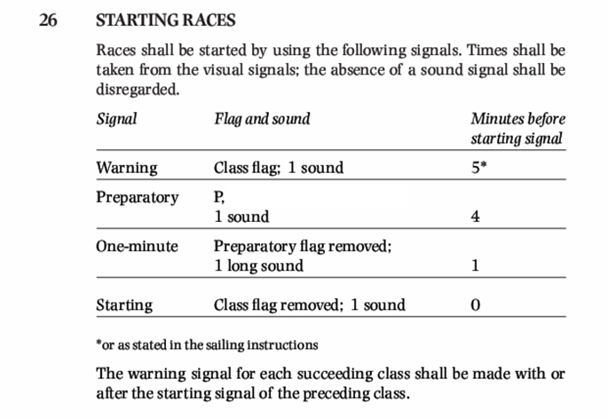

SAFETY REGULATIONS

A boat that retires from a race or leaves the racing area prior to the end of racing shall notify the race committee as soon as practical. The race committee can be notified by contacting any race committee boat verbally, or by VHF channel 65.

A boat shall carry all equipment required by her class rules, and the U. S Coast Guard. If not so specified, she shall also carry one USCG approved PFD, of the appropriate class, for each person on board.

TRASH DISPOSAL
Boats shall not put trash in the water.

RADIO COMMUNICATION
A boat shall neither make radio transmissions while racing nor receive radio communications not available to all boats. This restriction also applies to mobile telephones.

PRIZES
Prizes will be awarded to the boats placing first, second, and third in the regatta.

DISCLAIMER OF LIABILITY
Competitors participate in the regatta entirely at their own risk. See rule 4, Decision to Race. The organizing authority will not accept any liability for material damage or personal injury or death sustained in conjunction with or prior to, during, or after the regatta.
(Version 1.1, June 30, 2009

