

71th Annual Regatta

Sailing Instructions
Amended 8-11-2010

1. Rules
1.1 The Regatta will be governed by the Racing Rules of Sailing (RRS), the Prescriptions of the United States Sailing Association (US Sailing), the rules of the Class Associations of boats entered in this regatta (except as any of these are changed by these sailing instructions) and by these sailing instructions.

2. Entries
2.1 Classes of 5 boats or more are eligible.
2.2 Completed entry forms shall be in the hands of the Race Committee by the end of the Skippers’ Meeting or, on a day when there is no Skippers’ Meeting, before the Committee Boat leaves the dock.
2.3 A competitor who will not have reached his/her 19th birthday by December 31of the calendar year of the regatta, may race as a Junior by registering on the entry form that he/she is racing as a Junior.
2.4. Eligible competitors shall be members of a recognized yacht club or sailing association.

3. Safety
3.1 A boat shall carry all equipment required by her class rules. If not so specified, she shall also carry one USCG-approved PFD for each person on board.
3.2 A yacht requesting assistance should attempt to signal by waving an extended arm.

4. Notices to Competitors
4.1 Notices to competitors will be posted on the Official Regatta Notice Board located inside the FBYC Main Clubhouse Porch.

5. Changes to Sailing Instructions
5.1 Any change to these Sailing Instructions will be posted by the end of the Skippers’ Meeting on the day it will take effect or on a day when there is no Skipper’s Meeting, at least 30 minutes before the departure of the Committee Boat (departure time is normally one hour before the first warning signal).

6. Signals Made Ashore
6.1 Signals made ashore will be displayed on the Committee Boat at the FBYC Dock or on the flagpole on the Fishing Bay Dock.
6.2 Flag "AP" with two sound signals (one when lowered) means "The race is postponed". The warning signal will be made not less than 30 minutes after "AP" is lowered (with one sound).
6.3 Flag “N” hoisted over flag “H” with three sound signals means "The races are abandoned."
6.4 Flag "B" fully hoisted with one sound signal means "Protest time has begun".

7. Schedule of Races
7.1 Races are scheduled as follows:
Race Day Date Time of Warning Signal
1 Saturday, Aug 14 1130
subsequent races immediately following preceding race
2 Sunday, Aug 15 1000
subsequent race(s) immediately following preceding race
7.2 One race completed constitutes a regatta
7.3 Code flag “H” displayed on the Finish boat shall indicate no more racing today.

8. Class Designation
8.1 Classes will be assigned to their respective race courses at the skippers meeting.
8.2 The order of start for the first race may be named at the skippers meeting. The class flag, or other appropriate code flag substituting for a class flag, will be used to designate the class to start as described in 12. below and announced at the Skippers’ Meeting.
8.3 All Juniors will start with their respective classes.

9. Racing Area
9.1 The racing areas will be in the Fishing Bay area and mouth of the Piankatank River as shown in the chart in Appendix C. They are in the vicinity of the circles designated “A”, “B”, “C” and “D” on the chart (Appendix C).

10. The Course
10.1 The diagrams printed in Appendix D and Appendix D – Addendum show the courses including the approximate angles between legs, the order in which marks are to be rounded or passed, and the side on which each mark is to be left.
10.2 The course for each class will be designated by displaying the appropriate letter on the committee boat. If there is a number following the course designation, it will indicate the number of laps. (Example: "W" is windward/leeward, "W2" is windward/leeward/windward/leeward, etc.)
10.3 If the course letter is shown in red, the rounding marks are to be left to port. If the course letter is shown in green, the rounding marks are to be left to starboard.
10.4 The Committee Boat may or may not be moved for leeward finishes with courses "W" and "G", or for windward finishes with courses “E”, “T”, “O” or Opti Trap, depending upon conditions. The finish is between the Committee Boat and the adjacent finish mark, or other race committee boat, in either case. On course “E”, the finish is between a Racommitte boat and the finish mark to windward of the weather mark and the windward mark will not be a mark of the course during the last leg of the course designated.
10.5 For Course “E”, the Start Line will be to leeward of the Leeward Mark, and for Courses “W”, “T”, “G”, and “O”, the Start Line may be set to leeward of the Leeward Mark of the course to facilitate multiple fleets racing on the same course. If this is used, the Leeward Mark will not be a mark of the course during the first leg of the course and, in the event of a downwind finish, during the last leg of the course.
10.6 If the Start and Finish are in the middle of the windward leg, as in Courses H, F and M, for example, boats may cross the finish line at any time. (Gate is Open).

11. Marks
11.1 The rounding marks for all classes will be orange inflatable marks.
11.2 New Marks, as provided in rule 33, (Changing the Next Leg of the Course) will be yellow inflatable marks.
11.3 The starting and finishing marks will be inflatable marks, or committee boat(s).

12. The Start
12.1 Races will be started using Rule 26.
12.2 Optimist Green Fleet races may be started using the Whistle System as shown in Appendix F.
12.3 The starting line will be between a staff displaying an orange flag on the Race Committee signal boat at the starboard end of the line and the orange inflatable, or staff displaying an orange flag on another race committee boat, at the port-end.
12.4 For the Racing Area on which the Flying Scot class will sail, the starting line for the Flying Scot class will be between a staff displaying a yellow flag on the Race Committee signal boat and a yellow inflatable or staff displaying an yellow flag on another race committee boat at the port-end. All other classes’ starting line will be as indicated in 12.3. For Flying Scot class starts the orange inflatable in the area of the starting line is not a mark of the course during their class start.
12.5 A boat starting more than four (4) minutes after her class starting signal will be scored “DNS”.

13. Recalls
13.1 Race Committee may attempt to hail premature starters and boats that have incurred a starting penalty. Neither the promptness of the hail, nor the failure of the race committee to make this hail or of the competitor to hear the hail shall be grounds for redress. This changes rule 62.1(a).

14. Change of the Course After the Start
14.1 A change of course after the start will be signaled before the leading boat has begun the leg, although the new mark may not yet be in position. Any mark to be rounded after rounding the new mark may be relocated to maintain the original course configuration.
14.2 When in a subsequent change of course a new mark is replaced, it will be replaced with an original mark.

15. The Finish
15.1 The finish line will be between a staff displaying an orange flag on a race committee boat and an orange inflatable finishing mark, or staff displaying an orange flag on another race committee boat.

16. Time Limit
16.1 The time limit will be ninety (90) minutes.
16.2 Boats failing to finish within thirty (30) minutes after the first boat in the class will be scored "Did Not Finish". This changes rules 35, A4.2 and A5.

17. Protests
17.1 Protests shall be written on forms available from the Race Committee at the Protest desk adjacent to the Official Notice board and delivered to the Protest desk within the Protest Time Limit which will begin when the race committee boat docks and end one hour later. The beginning of the protest time will be announced as described in 6.4 above. The Protest time limit will be posted on the Regatta Notice Board.
17.2 The Protest Committee will hear protests in approximately the order of receipt and as soon as possible.
17.3 A boat may not protest a boat for an alleged breach of RRS 75.2 (Eligibility) with respect to ISAF Regulation 19.

18. Scoring
18.1 The Low-Point Scoring System, rule A4, will apply with the exceptions stated in 16.2 and 18.2.
18.2 Each skipper's total score will be the sum of his/her scores for all races, excluding his/her worst score if six or more races are sailed.
18.3 When scoring overall results, Juniors and adults will be scored together. Juniors will also be scored separately.

19. Awards
19.1 Awards will be presented as follows:
Three for five starters
Four for six or more starters

Appendix D: Diagram of Courses

Appendix C: Racing Area Chartlet
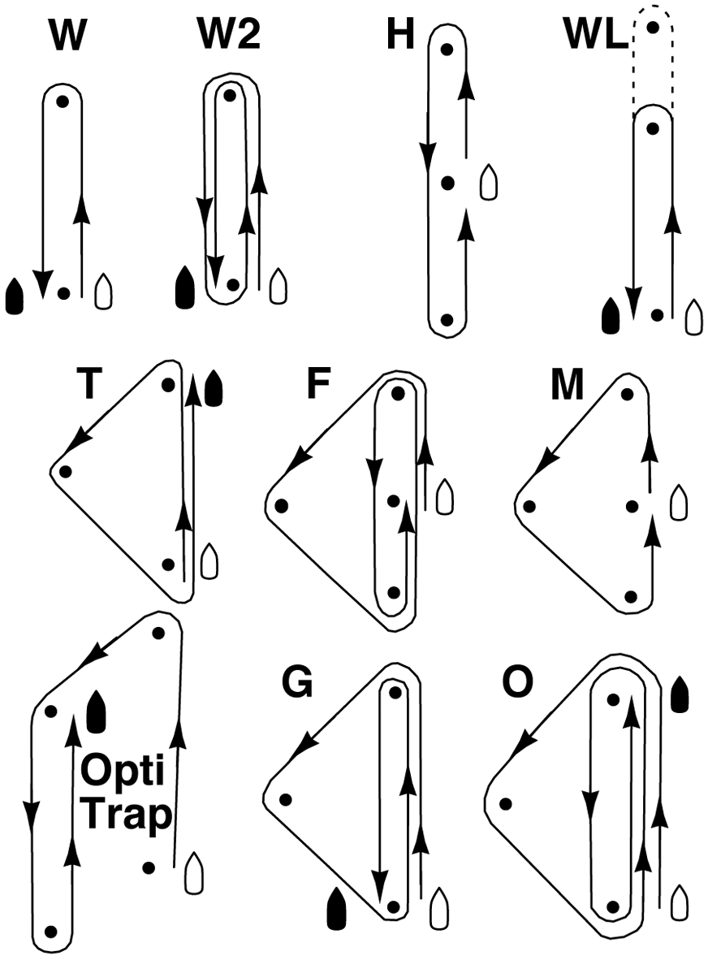
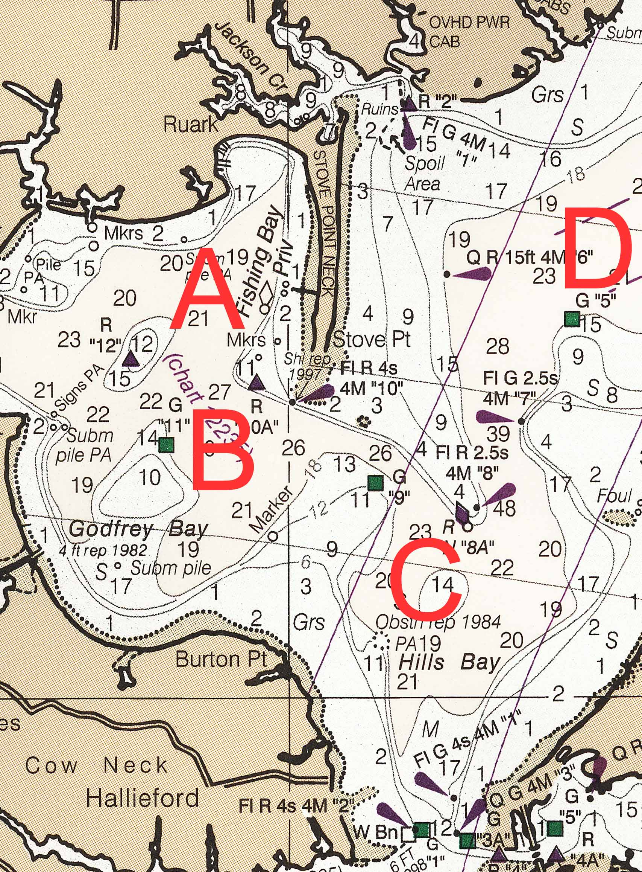

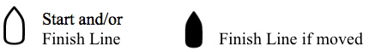

Appendix D - Addendum

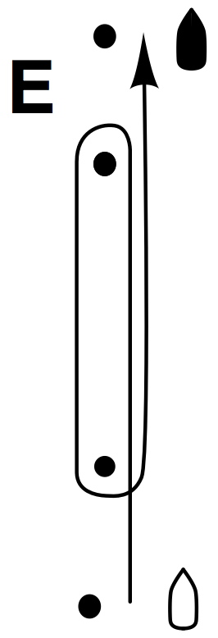
Course Diagram
Finish
Course E –Start-1-2-finish

Course E2 (Not shown) –
1
Start-1-2-1-2-Finish

2
Start
Appendix F

This system is recommended primarily for small-boat racing and makes it unnecessary for competitors to use stop watches. Supplemental visual course and recall signals are also recommended when practicable.
1. Course and postponement signals may be made orally
2. Audible signals will govern, even when supplemental visual signals are also used.
3. The starting sequence will consist of the following sound signals made at the indicated times:

Signal Sound Time Before Start
Warning 3 long 3 minutes
Preparatory 2 long 2 minutes
1 long, 3 short 1 minute, 30 seconds
1 long 1 minute
3 short 30 seconds
2 short 20 seconds
1 short 10 seconds
1 short 5 seconds
1 short 4 seconds
1 short 3 seconds
1 short 2 seconds
1 short 1 second
1 long 0 GO!

4. Signals will be timed from their commencement.
5. A series of short signals may be made before the sequence begins in order to attract attention
6. Individual recalls will be signaled by the hail of the sail number (or some other clearly distinguishing feature) of each recalled yacht. Code flag "X" need not be displayed.
7. Failure of a competitor to hear an adequate course, postponement, starting sequence, or recall signal will not be grounds for redress.

Schedule of Events

Saturday, August 14, 2010
Continental Breakfast 0800
Registration 0900 - 1015
Skippers Meeting 1000
First Warning Signal 1130
Followed by subsequent races
Followed by entertainment 1700 - 2100
AOD Adults Dinner 1800

Sunday, August 15, 2010
Continental Breakfast 0800
First Warning Signal 1000
Followed by subsequent races
Followed by refreshments and awards

99900.02100 EMF_US 27942085v4

