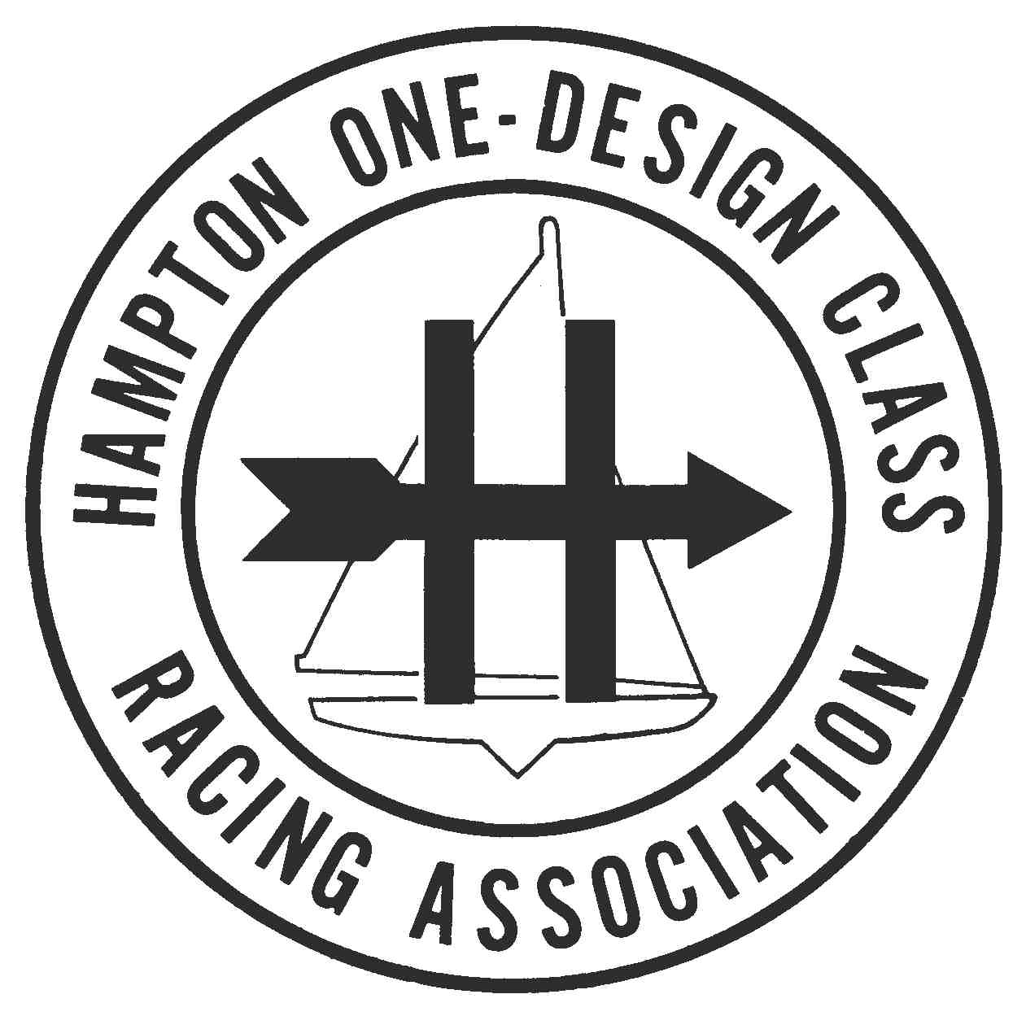
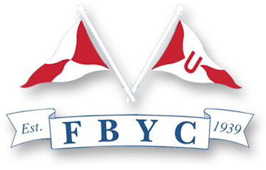

Schedule of Events
2010 Hampton One-Design National Championship

August 20, 21, & 22
Fishing Bay Yacht Club

Time Event Location

Friday, August 20, 2010

10-11:50 a.m. Registration, Equipment Check FBYC

12:00 p.m. Skippers’ Meeting FBYC
(Lunch available from Mobile Concession)

2:00 p.m. Warning Signal (Race 1) East or South of Stove Point
- Race 2 immediately after Race 1

6:30 p.m. Cocktails (Beer & Wine) FBYC
7:30 p.m. Dinner (Grilled Chicken)

8:45 Annual Class Meeting

Saturday, August 21, 2010

10:30 a.m. - Warning Signal (Race 3)
- Race 4 immediately after Race 3
- Race 5 immediately after Race 4

6:30 p.m. Cocktails (Beer, Wine, Mixers, BYOB) FBYC Poolside

7:30 p.m. Dinner (Grilled Flank Steak)

Sunday, August 22, 2010

10:30 a.m. Warning Signal (Race 6)
- Make-up race immediately after
Race 6 (if required)
- No races will be started after 3 p.m.

After Sailing Awards Ceremony FBYC

