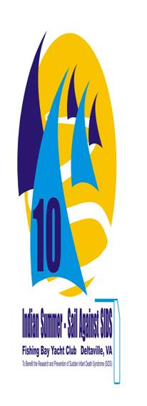

Indian Summer - Sail Against SIDS Regatta
Saturday, October 2, 2010

****Online Reservations Requested by September 30, 2010****

The Indian Summer – Sail Against SIDS Regatta is hosted by FBYC. All FBYC Members are encouraged to participate. Proceeds will benefit the research and prevention of Sudden Infant Death Syndrome (SIDS). SIDS is the leading cause of death in infants between the ages of 1 and 12 months. There is currently no known cause or cure.

Starts will be offered for the following classes: 420, Flying Scot, Front Runner, Laser, Laser Radial, Mobjack, and Optimist. Additional classes may be added at the discretion of the Event Chair or the One Design Division Commander. Optimists will be divided into Red, Blue, White and Green fleets, as defined by USODA. There may be a separate start for the Green fleet.

Event Chair: Matthew Braun matt.braun@thalhimer.com c~(804) 640-3184; h~(804) 266-4533; o~(804) 697-3419.

Registration: Information regarding registration, classes, social activities, awards will be available at www.fbyc.net/Events/. On-line registration will be available and pre-registration is encouraged. Discounted pre-registration will end September 30, 2010. Registrations will be accepted until 10:00am on October 2, 2010.
Program:
Saturday, October 2, 2010
Registration and continental breakfast 0800
Skippers Meeting 1000
First Warning Signal 1100
Followed by subsequent races
Oktoberfest 1500-1700

Entry Fees: $10 Single handed, $15 all other entries

The Regatta is sanctioned as a separate event for CBYRA High Point awards in certain classes as shown in the CBYRA One Design Schedule.

