October 16-17, 2010
Fishing Bay Yacht Club
Deltaville, Virginia

1. RULES
1.1 The regatta will be governed by the rules as defined in The Racing Rules of Sailing and the rules of the International Laser Class Association.
1.2 The organizing authority is Fishing Bay Yacht Club

2. NOTICES TO COMPETITORS
2.1 Notices to competitors will be posted on the official notice board located in the 1st floor screened porch of the main clubhouse.

3. CHANGES TO SAILING INSTRUCTIONS
3.1 Any change to the sailing instructions will be posted before 0900 on the day it will take effect, except that any change to the schedule of races will be posted by 2000 on the day before it will take effect.

4. SIGNALS MADE ASHORE
4.1 Signals made ashore will be displayed on the flagpole at the Fishing Bay YC dock.
4.2 When flag AP is displayed ashore, ‘1 minute’ is replaced with ‘not less than 30 minutes’ in the race signal AP.

5 SCHEDULE OF RACES
5.1
Saturday, October 16
Registration 0800-1000
Skippers Meeting at 1000
Warning signal for first race 1100

Sunday, October 17
Breakfast 0800
First Warning Signal 1000

5.2 On Sunday, no warning signal will be made after 1500.

6 CLASS FLAG
6.1 The class flag will be white with the red class logo.

7 RACING AREAS
7.1 Attachment 1 shows the location of the racing area.

8 THE COURSES
8.1 The diagrams in Attachment 2 show the courses, including the approximate angles between the legs, the order in which marks are to be passed, and the side on which each mark is to be left.

9 MARKS
9.1 Marks will be orange.
9.2 New marks will be yellow.

10 THE START
10.1 Races will be started using rule 26 with the warning signal given 5 minutes before the starting signal.
10.2 The starting line will be between a staff displaying an orange flag on the race committee boat at the starboard end and the port-end starting mark.
10.3 Boats starting later than 5 minutes after her starting signal will be scored Did Not Start. This changes rule A4.
10.4 Add to rule 29.1 ‘The race committee will attempt to hail boats on the course side of the line at the start, or boats in violation of 30.1. However, the absence of a hail, or the failure of a competitor to hear such hail, shall not constitute grounds for redress.

11 CHANGE OF THE NEXT LEG OF THE COURSE
11.1 To change the next leg of the course, the race committee will lay a new mark (or move the finishing line) and remove the original mark as soon as practicable. When in a subsequent change a new mark is replaced, it will be replaced by an original mark.

12 THE FINISH
12.1 The finishing line will be between the vessel displaying an orange flag on the starboard end, and the port-end finishing mark.

13 TIME LIMIT
13.1 Boats failing to finish within 30 minutes after the first boat sails the course and finishes will be scored Did Not Finish. This changes rules 35 and A4.

14 PROTESTS AND REQUESTS FOR REDRESS
14.1 Competitors intending to protest shall inform the Race Committee immediately after finishing and before communicating with coaches or spectators. Boats should first sail to the non-course side of the Finish Boat and report to the Finish Boat. Boats that do not finish shall report their intent to protest to any Race Committee Boat at the first possible opportunity. This adds to RRS 61.1(a)
14.2 Protest forms are available inside the 1st floor of the main clubhouse.
14.3 The protest time limit is 1 hour and will begin when the race committee boat has docked. This changes rules 61.3 and 62.2.
14.4 Notices will be posted within 10 minutes of the protest time limit to inform competitors of hearings in which they are parties or named as witnesses. Hearings will be held in the jury room, located on the 2nd floor of the main club house at the time posted on the notice.
14.5 Notices of protests by the race committee will be posted to inform boats under 61.1b
14.6 On the last day of the regatta, a request for reopening a hearing shall be delivered within the protest time limit on the last day of the regatta. This changes rule 66.

15 SCORING
15.1 The Low Point Scoring System, Appendix A4, will be used.
15.2 To determine the overall masters winner, for each individual race that counts, 3 points shall be added to Apprentice Masters (35-44), 2 points to Masters (45-54), 1 point to Grand Masters (55-64) and no points to Great Grand Masters (65 & over).
15.3 A sailor’s age will be determined as of 12:01 AM on the first day of racing. In the event that a sailor was born at 12:01 AM on the first day of racing, a coin flip will be used to determine which age category the sailor will be scored in.
15.4 Ties shall be broken in favor of sailors in the older age category. In the case of a tie between competitors in the same age category it shall be broken in accordance with A8.
15.5 A minimum of 1 race is required to be completed to constitute a series.
15.6 When 5 or more races have been completed, a boat’s series score will be the total of her race scores excluding her worst score.

16 SAFETY REGULATIONS
16.1 A life jacket or other adequate personal buoyancy device shall be worn at all times while racing. Competitors are subject to US Coast Guard regulations. This changes rule 40.
16.2 A boat that retires from a race shall notify the race committee as soon as possible.

17 EQUIPMENT
17.1 Sailors may sail with a full, radial or 4.7 rig as long as the sail has the same sail number they registered with and they must sail with the rig they leave the dock with.

ATTACHMENT 1 | ATTACHMENT 2
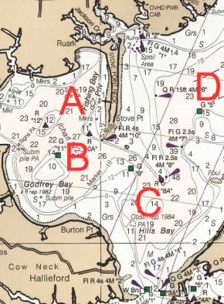 | 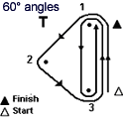  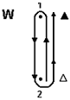  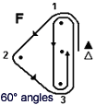  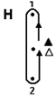

http://www.fbyc.net
http://www.laserdistrict11.org/

