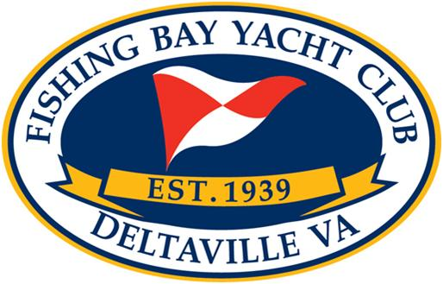
NOTICE OF RACE
WINDMILL NATIONAL CHAMPIONSHIP
Windmill Class Association
Fishing Bay Yacht Club July 18-21, 2013
1 RULES
1.1 The regatta will be governed by the rules as defined in the current issue of The Racing Rules of Sailing, 2013-2016 the rules of the Windmill Class By Laws XIII, this Notice of Race and the Sailing Instructions. In case of conflict, the Sailing Instructions shall prevail.
2 ELIGIBILITY AND ENTRY
2.1 This regatta is open to all Windmill Class boats. Participants must meet all regatta requirements and have completed a registration form and waiver signed by the skipper and crew. All Skippers must be in good standing with the Windmill Class Association and must have paid all event fees before becoming official competitors. Registration may be completed at the following link: www.fbyc.net
3 FEES
3.1 Required fees are as follows: Registration per boat $170 (this includes 2 dinners, additional dinners may be purchased online)
Added LATE FEE of $15.00 for registrations received after July 11, 2013. For additional information contact: Alex Alvis at (804) 370-8241 or alexalvis@comcast.net
4 SCHEDULE
4.1 Early Check in, Measurement and Inspection and Junior Championship Racing, Thursday July 18, 2013, 1200 -1800. Junior Nationals 1400 1700
4.2 Registration, Measurement and Inspection:
Friday morning July 19, 0800 - 1000 Skippers Meeting 1000
4.3 Saturday evening July 20, WCA Annual Meeting and Dinner
4.4 Schedule of racing:
Date 1st Warning No start after
Friday July 19 1200 1600
Saturday July 20 1000 1600
Sunday July 21 1000 1200
4.5 As many races will be run each day as deemed practical by the Race Committee, with input from
the designated Windmill Class Representatives chosen by the class association.

5 MEASUREMENTS
Mainsails and jibs not previously measured must be measured and approved prior to the first race in accordance with Windmill Class bylaws Rule XIII.5. In addition to sail measurements, one or more of the following measurements may be taken in accordance with Windmill Class Rule XIII.5.E : hull weight, mast bands, rudder, and dagger board ..
6 SAILING INSTRUCTIONS
The sailing instructions will be available on FBYC website and at registration / check-in.
7 VENUE
7.1 Racing will take place in Fishing Bay near the mouth of the Piankatank River directly south of Fishing Bay Yacht Club.
7.2 FBYC will provide coffee and light breakfast each day, included in the registration fee for crews. The Club will provide a meal for the Annual Regatta Dinner on Saturday evening, July 20, at the clubhouse, also included in the registration fee. The club swimming pool will be available for use by all participants and family during normal pool hours (1100 until sunset, weather permitting).
7.3 The courses will be either a windward-leeward or triangle-windward-leeward course around buoys or any other course described in the Sailing Instructions.
9 SCORING
9.1 The Low Point System of Appendix A will apply.
9.2 At least three races are required to constitute a National Championship.
9.3 When fewer than 5 (five) races have been completed, a boat's series score will be the total of her race scores.
10 PRIZES will be given to Skipper and Crew of the top 6 places. The first place boat will also be awarded the Windmill Class Association National Championship Trophy, a perpetual trophy. Prizes other than place in regatta racing may also be awarded at the discretion of the Class officers.
11 DISCLAIMER OF LIABILITY Competitors participate in the regatta entirely at their own risk. See RRS rule 4, Decision to Race. The organizing authority will not accept any liability for material damage or personal injury or death sustained in conjunction with or prior to, during, or after the regatta.

