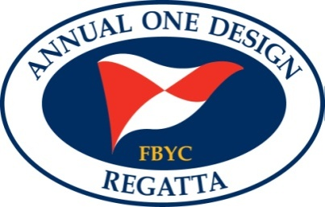
Notice of Race
Fishing Bay Yacht Club 73rd Annual One Design Regatta
August 10 and 11 2013

Fishing Bay Yacht Club, Deltaville VA

1. Rules
The Regatta will be governed by the Racing Rules of Sailing (RRS), 2013 – 2016, except as modified by the Sailing Instructions.
2. Eligibility and Entries
2.1 The Annual One Design regatta is open to the following classes – Albacores, Flying Scot, Front Runner, Hampton OD, Lasers (Full and Radial) Optimist Dinghy (Red, Blue, White and Green fleets),Typhoon and 420.
2.2 Classes with 5 or more boats entered will be given individual starts
2.3 Additional classes may be added at the discretion of FBYC.
2.4 Each competitor will be responsible for their boats being in compliance with class rules.
3. Fees
Event Packages:
$85.00 Double Handed boat (includes two dinner tickets and one t-shirt)
$65.00 Single Handed Boat (includes one dinner ticket and one t-shirt)
$35.00 Junior package (includes one dinner ticket and one t-shirt)
A La Carte Prices:
Double handed boat $55.00
Single handed boat Adult $40.00
Junior Competitor $15.00
Adult Dinner $15.00
Child under 8 dinner: $10.00
See website for menu

4. Schedule of Events
Friday, August 09, 2013
Early check in and registration 1900
Saturday, August 10, 2013
Continental Breakfast 0800
Registration 0800 - 1000
Skippers Meeting 0900
First Warning Signal 1130
Followed by subsequent races
Post Race Cocktails 1700
Dinner 1800
Live Music and Dancing 1900-2200

Sunday, August 11, 2013
Continental Breakfast 0800
First Warning Signal 1000
Followed by subsequent races
Followed by refreshments and awards
5. Advance Registration: Competitors may register in advance on the web at www.FBYC.net. The entry deadline is 8-08-13 after which a late fee of $5.00 will apply.
6. Sailing Instructions. The sailing instructions will be available at registration and online at www.FBYC.net
7. Scoring - One completed race shall constitute the regatta.

8 Discipline : All competitors are expected to maintain the highest level of conduct throughout the entire event. When the Protest Committee, from its own observation or a report received from any source believes that a competitor may have committed a breach of a rule, good manners, or sportsmanship, or may have brought the sport into disrepute, it may call a hearing. After a proper hearing the penalty may range from a reprimand to dismissal from the regatta and additional action may be taken under RRS 69.

9. Trophies will be awarded to competitors placing first through 3rd in all classes

10. Further information. Contact Event Committee Chair David Hinckle at (804) 370-7650 or email david@blueprintingservicesva.com. Check the website for further information.

