September 7-8, 2013
Deltaville, Virginia

1. RULES
The regatta will be governed by the rules as defined in The Racing Rules of Sailing and the rules of the International Laser Class Association.

2. NOTICES TO COMPETITORS
Notices to competitors will be posted on the official notice board located in the 1st floor screened porch of the main clubhouse.

3. CHANGES TO SAILING INSTRUCTIONS
Any change or addendum to the sailing instructions will be posted by 0900 on the day it will take effect, except any change to the schedule of races will be posted by 2000 on the day before it will take effect.

4. SIGNALS MADE ASHORE
4.1 Signals made ashore will be displayed on the flag pole on the club dock on Fishing Bay.
4.2 If a postponement is signaled ashore, the warning signal will be made not less than 45 minutes after flag AP is lowered. This changes RRS - Race Signals – “AP”.

5. SCHEDULE
  - Saturday, September 7
  - Registration, check-in, and Breakfast 0800-0945
Skippers Meeting 1000
Warning signal for first race 1100
Followed by subsequent races
Dinner 1800-2100
  - Sunday, September 8
Breakfast 0800-0900
Warning signal for first race 1000
Awards to follow as soon as possible after the last race.
  - On Sunday no warning signal shall be made after 1500.
5.5 A maximum of 9 races to be sailed with no limit as to how many races may be sailed on a particular day.
5.6 If the Race Committee intends to start another race on the same day, it will display the 2nd substitute (with no sound) while boats are finishing.
5.7 Competitors are requested to check-in prior to their first race of the day by sailing past the stern of the RC Signal Boat and hailing their sail number and being acknowledged. Only the Race Committee can protest a breach of this instruction. This change RRS 60.1

6 CLASS FLAG
The class flag will be the Laser logo.

7 RACING AREAS
7.1 Attachment 1 shows the location of the racing areas.
7.2 The racing area to be used will be posted on the official Notice Board according to section 3.

8. COURSES
8.1 The diagrams in Attachment 2 show the courses, including the approximate angles between the legs, the order in which marks are to be passed, and the side on which each mark is to be left.
8.2 The course will be designated on lettered/numbered placards on the Starboard side of the Race Committee Signal Boat.
8.3. Total legs for courses W and H (denoted by numerals) may be added or subtracted but the basic positions of start/finish lines remain the same.
8.4 If numeral pennant 9 is flown during the starting sequence, after rounding the windward mark, boats will be required to round an offset mark. For courses “F” and “T”, the offset is not a mark of the course on the first reaching leg.
8.5 Leeward Gate (Course H only) – When the RC intends to set a leeward gate instead of a single leeward, code flag “G” will be displayed on the RC Signal Boat. All boats shall sail between the 2 leeward marks in the direction from the last mark and round the port leeward mark to port or the starboard leeward mark to starboard. If only one leeward mark (no code flag “G” displayed) is in place boats shall leave it to port.

9 STARTING AND FINISHING
9.1 The starting and finishing lines will be between the staff displaying an orange flag on a Race Committee Signal Boat at the starboard end, and the course side of the port-end orange inflatable.
9.2 A boat starting later than 5 minutes after her starting signal will be scored “Did Not Start (DNS)”. This changes RRS A4.

10 MARKS & CHANGE OF THE NEXT LEG OF THE COURSE
10.1 Marks will be orange inflatable marks
10.2 To change the next leg of the course, the Race Committee will lay a new yellow mark (or move the finishing line) and remove the original orange mark as soon as practicable. When, in a subsequent change a new mark is replaced, it will be replaced by an original orange mark.

11 TIME LIMIT
11.1 The time limit for the first boat to finish is 90 minutes.
11.2 A boat still racing, but not yet finished 30 minutes after the first boat sails the course and finishes, will be scored Time Limit Expired (TLE) and shall receive points equal to the number of finishers plus one. This changes rules 35, A5, and A4.

12 PROTESTS AND REQUESTS FOR REDRESS
12.1 Both Section B (Post-Race Penalties) and section C (Expedited Hearings of Appendix T (Alternate Procedures for Dispute Resolution) are in effect for this regatta. See Section 13.3 below for changes in penalties under Section B.
12.2 A boat intending to protest another boat must so notify the Race Committee by hail immediately after finishing or retiring and before communicating with coaches or spectators and must be acknowledged by the Race Committee. Boats should sail to the non-course side of the Finish Boat and report to the Finish Boat. This notification must include the sail number of the boat being protested.
12.3 Protest forms are available at the Protest Desk inside the 1st floor of the main clubhouse. Protests, requests for redress or reopening, and requests to participate in applicable hearings must be in writing and delivered to the Protest Desk within the appropriate time limit.
12.4 The protest time limit is one (1) hour after the Race Committee Signal boat has docked. This protest time limit will be posted on the Official Notice Board. If the Race Committee posts a list of boats scored OCS, ZFP or BFD, on the Official Notice Board before expiration of the protest time limit, the time limit for filing a request for redress based on such a score shall be no later than 30 minutes after the protest time limit. This changes RRS 61.3 and 62.2
12.5 A notice of protests and requests for redress and a tentative schedule of hearings will be posted on the Official Notice Board no later than 30 minutes after the expiration of protest time. This posting will also serve as the notification of Race Committee and Protest Committee protests required in
RRS61.1 (b).
12.6 Notice of a redress hearing properly posted on the Official Notice Board shall serve as notice to all boats, whether listed as parties to the hearing or not, that they may attend the hearing.
12.7 It is the responsibility of each skipper to check the Official Notice Board to see if his boat has been cited in a Protest or scored OCS, ZFP, or BFD. Failure to appear for a protest hearing will be considered avoidable absence under RRS 63.3 (b).
12.8 Hearings will be held in the jury room, located on the 2nd floor of the main club house at the time posted on the notice.
12.9 On the last day of the regatta, a request for reopening a hearing shall be delivered within the protest time limit. This changes RRS 66.

13. SCORING
13.1 The Low Point Scoring System, Appendix A4, will be used.
13.2 When 5 or more races have been completed, a boat’s series score will be the total of her race scores excluding her worst score. This changes RRS - A2
13.3 Post-race penalties will be available as per Appendix T, Section B (Post-Race Penalties. However, Section B penalties are changed as follows:
a. The penalty under T2.2 (a) will be 30%.
b. The penalty under T2.2 (b) will be 40%
This changes RRS Appendix T2.2
13.4 To determine the overall masters winner, for each individual race that counts, 3 points shall be added to Apprentice Masters (35-44), 2 points to Masters (45-54), 1 point to Grand Masters (55-64) and no points to Great Grand Masters (65 & over). This changes RRS A4.1.
13.5 A sailor’s age will be determined as of 12:01 AM on the first day of racing. In the event that a sailor was born at 12:01 AM on the first day of racing, a coin flip will be used to determine which age category the sailor will be scored in.
13.6 Series score ties shall be broken in favor of sailors in the older age category. This changes RRS A8. In the case of a tie between competitors in the same age category it shall be broken in accordance with A8.
13.7 One race completed constitutes a regatta.
13.8 Prizes will be awarded for each age group, for first female, and for first overall.
13.9 The overall winner will be the 2013 Chesapeake Bay Laser Masters Champion

14 SAFETY REGULATIONS
14.1 A life jacket or other adequate personal buoyancy device shall be worn at all times while racing. Competitors are subject to US Coast Guard regulations. This changes RRS 40.
14.2 A boat that retires from a race shall notify the race committee as soon as possible.

15 EQUIPMENT
Competitors may sail with a full, radial, or 4.7 sail and spars as long as the sail numbers have been registered for the regatta, and they must sail with the rig with which they left the launch site.
1 7 DISCLAIMER OF LIABILITY
Competitors participate in the regatta entirely at their own risk. See RRS #4, Decision to Race. The organizing authority will not accept any liability for material damage or personal injury or death sustained in conjunction with or prior to, during, or after the regatta.

ATTACHMENT 1 | ATTACHMENT 2
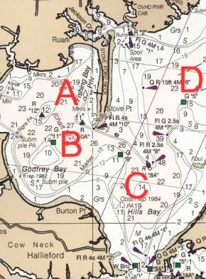 | 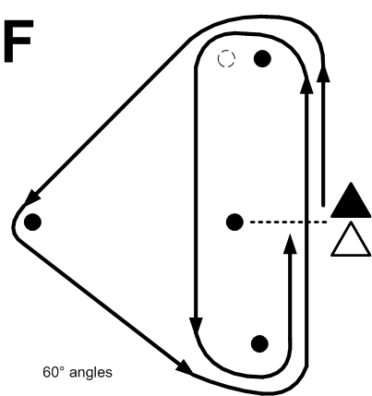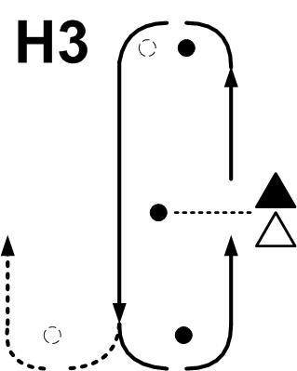  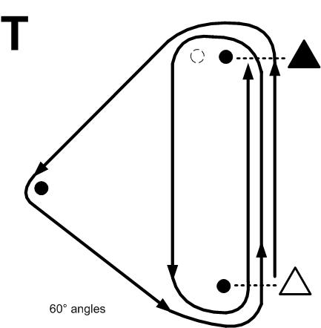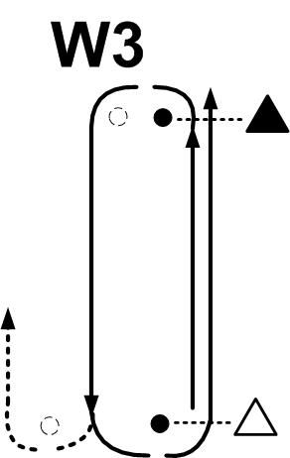  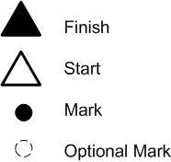  The above illustrations represent sample courses only. Total legs for courses W, and H, (denoted by numerals) may be added or subtracted but the basic positions of start/finish lines remain the same.[ Sec. 8.3]

