
Flying Scot® Sailing Association
2014 Atlantic Coast Championships
And Capitol District Championship
September 20-21, 2014
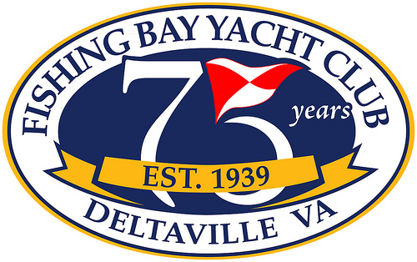
Hosted by Fishing Bay Yacht Club
Deltaville, Virginia

Sailing Instructions -- PRELIMINARY
1. RULES
1.1 The regatta will be governed by the Rules as defined in The Racing Rules of Sailing
(2012-2016).
1.2 U.S. Sailing Prescriptions to RRS 60, 63.2 and 63.4b will not apply.
1.3 Discrepancies between the NOR and these Sailing Instructions, the Sailing Instructions
take precedence.

2. ENTIRES
2.1 The Atlantic Coast Championship (ACC) is open to current Active, Life, Junior, Club,
and Family Members as defined in the FSSA Constitution. FSSA dues and club boat
registration fees must be paid to the FSSA prior to the event.
2.2 A Challenger Division will be sailed
2.3 Competitors must choose between the Championship and Challenger divisions prior to
the close of registration. Boats in the Challenger division shall fly a orange streamer (to
be provided at the Competitors’ Meeting) about 1 foot above the clew of the mainsail.
2.4 Participants that are members of fleets within the Capitol District will automatically be
entered in the Capitol District Championship.

3. NOTICES TO COMPETITORS
Notices to competitors will be posted on the Official Notice Board located in front
(landside) of FBYC Main Clubhouse.

4. CHANGES IN THE SAILING INSTURCTIONS
Addendums or changes to these Sailing Instructions will be posted by 0930 on Saturday
and Sunday by 0900, except any change to the racing schedule will be posted before 1800
on the day prior to it taking effect. .

5. Signals Made Ashore
5.1 Signals made ashore will be displayed on the flagpole on the Fishing Bay dock.
5.2 The warning signal will be made not less than 45 minutes after "AP" is lowered with
one sound. This changes RRS – Race Signals “AP”
5.3 Signals made ashore shall be for all Divisions.
6. SCHEDULE
6.1 Racing will be Saturday and Sunday with a maximum of five (5) races for the regatta.
See the schedule below. Three races are scheduled for Saturday and two races are
scheduled for Sunday. The number of races each day may be adjusted depending
upon conditions.

6.2 Saturday, September 20th

0800 -0930 On-site Registration, Continental Breakfast
0930 Competitors' Meeting
1000 RC departs for race course
1130 Warning Signal for First Race
1800 Dinner at FBYC

Sunday, September 21st

0800 – 0900 Continental Breakfast
0900 RC departs for race course
1000 Warning Signal for First Race
Post-Race Social and Awards Ceremony

6.3 Subsequent races each day will be held as soon as possible after the end of the
previous race. If at the finish, the RC displays code flag “A” (no sound), it will
mean no more racing that day.
6.4 No Warning Signal will be made after 1300 on Sunday, October 21st.

7. RACING AREA
The race area will be in the mouth of the Piankatank River (Area “D” as denoted on the
chartlet shown in Appendix A.)

8. COURSES
8.1 The diagram in Appendix B show sample courses, including the approximate angles
between the legs, the order in which marks are to be passed, and the side on which each
mark is to be left.
8.2 The course will be designated by numbered placards displayed on the
starboard side of the Race Committee Signal Boat.
8.3 The windward mark will have an offset mark which shall be left to port.
8.4 A leeward gate will be used. Boats will sail between the gate marks in the direction from
the previous mark and round either gate mark.

9. MARKS
9.1 Original marks of the course will be orange cylinders.
9.2 The windward offset mark will be a white ball.
9.3 Change mark will be yellow tetrahedron. If the course is changed again, the original
mark will be used.
9.4 The Race Committee may adjust the angle of a gate without making any signals.

10. CHECK-IN (on water)
Each day, when the committee boat is anchored and displays code flag “L”, competitors shall come within hail and check-in by hailing their sail number until acknowledged by the race committee. .

11. THE START
10.1 Races will be started per RRS 26.
10.2 The class/warning flags are as follows:
- Championship Division: Red Flying Scot logo on a white field.
- Challenger Division: Blue Flying Scot logo on a white field
10.3 The start line will be between a staff displaying an yellow flag on a
race committee boat and the course side of a yellow inflatable mark, or a staff
displaying a yellow flag on another Race Committee Boat.
10.4 The warning signal for each race may be preceded by short repetitive sound
signals to alert competitors that a starting sequence is about to begin (not a timed
signal)
10.5 A boat starting later than 4 minutes after her starting signal will be scored DNS
without a hearing. This changes RRS 63.1,A4.1 and A5

12. RECALLS
As a courtesy, the Race Committee will attempt to hail OCS boats by sail or hull number
(if applicable) on Individual Recalls via VHF radio, only. The hail will be made on VHF
channel 69. General Recalls will also be announces on the radio. Failure of the race
committee to make this hail, failure of a boat to hear the hail, her position in the
sequence of notifications or promptness of notification will not be valid grounds for
redress. This changes RRS 62.1(a) .

13. THE FINISH
The finish line will be between a staff displaying an yellow flag on a
race committee boat and the course side of a yellow inflatable mark, or a staff
displaying a yellow flag on another Race Committee Boat.

14. TIME LIMITS
14.1 The time limit for the first boat to pass the first mark will be 40 minutes and for the
first boat to sail the course and finish will be two (2) hours. If either of these limits is
not met, the race will be abandoned.
14.2 Boats failing to finish within 20 minutes of the first boat to finish to sail the course and
finish will be scored “TLE” (Time limit expired) without a hearing. This changes RRS
35, 63.1 and A11.

15. PROTESTS AND REDRESS
15.1 A boat intending to protest shall inform the race Committee boat at the finish of that
race including the sail number of the boat she intends to protest.
This changes RRS 61.1(a).
15.2 Protests shall be in writing and delivered to the Protest Desk, located in the
screen porch of the Main club house, within the Protest Time Limit.
15.3 The Protest Time Limit will begin when the Race Committee Signal Boat
docks and ends one hour later. The Protest Time Limit will be posted on the Regatta
Notice Board.
15.4 Notices of protests will be posted within 30 minutes after the end of the protest time
limit. Protests by the race committee or protest committee will be posted on the
official notice board. This posting constitutes notice required by RRS 61.1(b) .
15.5 Hearings will be held as soon as possible after racing each day in the Library on the
second floor of the FBYC Clubhouse.
15.6 USSA prescription to RRS 63.2 shall not be in effect. This changes RRS 63.2.

16. SCORING
16.1 The Low Point System of RRS Appendix A will be used.
16.2 Five (5) races are scheduled for the regatta and there will be no throw outs. This
changes RRS A2.
16.3 Each Division (Champion and Challenger) will be scored separately.
16.4 Capital District registrants will be scored within the District boats to
determine the Capital District Champion.
16.5 Boats scored TLE will be awarded points one (1) greater than the last boat to
finish. This changes RRS A4.2
16.5 One race completed will constitute a regatta.

17. VHF RADIO
In addition to the VHF radio hails mentioned in Section12, the race committee may use
VHF channel 69 to provide other information to competitors.

18. TOWING AND SUPPORT BOATS
18.1 Support boats shall not be used, except for those available to all competitors
provided by the Organizing Authority.
18.2 Towing boats to and from the race area will be ONLY if towing is made available
to all participants. Otherwise, a towed boat without consent of the race committee
shall be disqualified without an hearing. This changes RRS 63.1. Exception to this
rule may be made by the Protest Committee in extenuating circumstances such as
breakdowns, illness, or other factors appropriate. Protest under this rule may only
be made by the Protest or race Committees. This changes RRS 60.1(a).

19. PRIZES
19.1 Prizes will be awarded to the skipper and crew of the top five (5) boats in the
Champion Division.
19.2 The Challenger Division prizes will be awarded to the top three (3) boats.
19.3 The top scoring Capitol district boat will be awarded the District’s Championship.

20. Contact Information
Debbie Cycotte Regatta Co-Chair 804-761-3048
Noel Clinard Regatta Co-Chair 804-338-4066
Rick Klein Principal Race Officer 804-832-5079
Brooks Zerkel Chief Judge 804-909-7400

21. Disclaimer of Liability
Competitors participate in this regatta entirely at their own risk. See RRS 4, Decision to
Race. The Organizing Authority will not accept any liability for material damage or person
injury or death sustained in conjunction with or prior to, during or after the regatta.

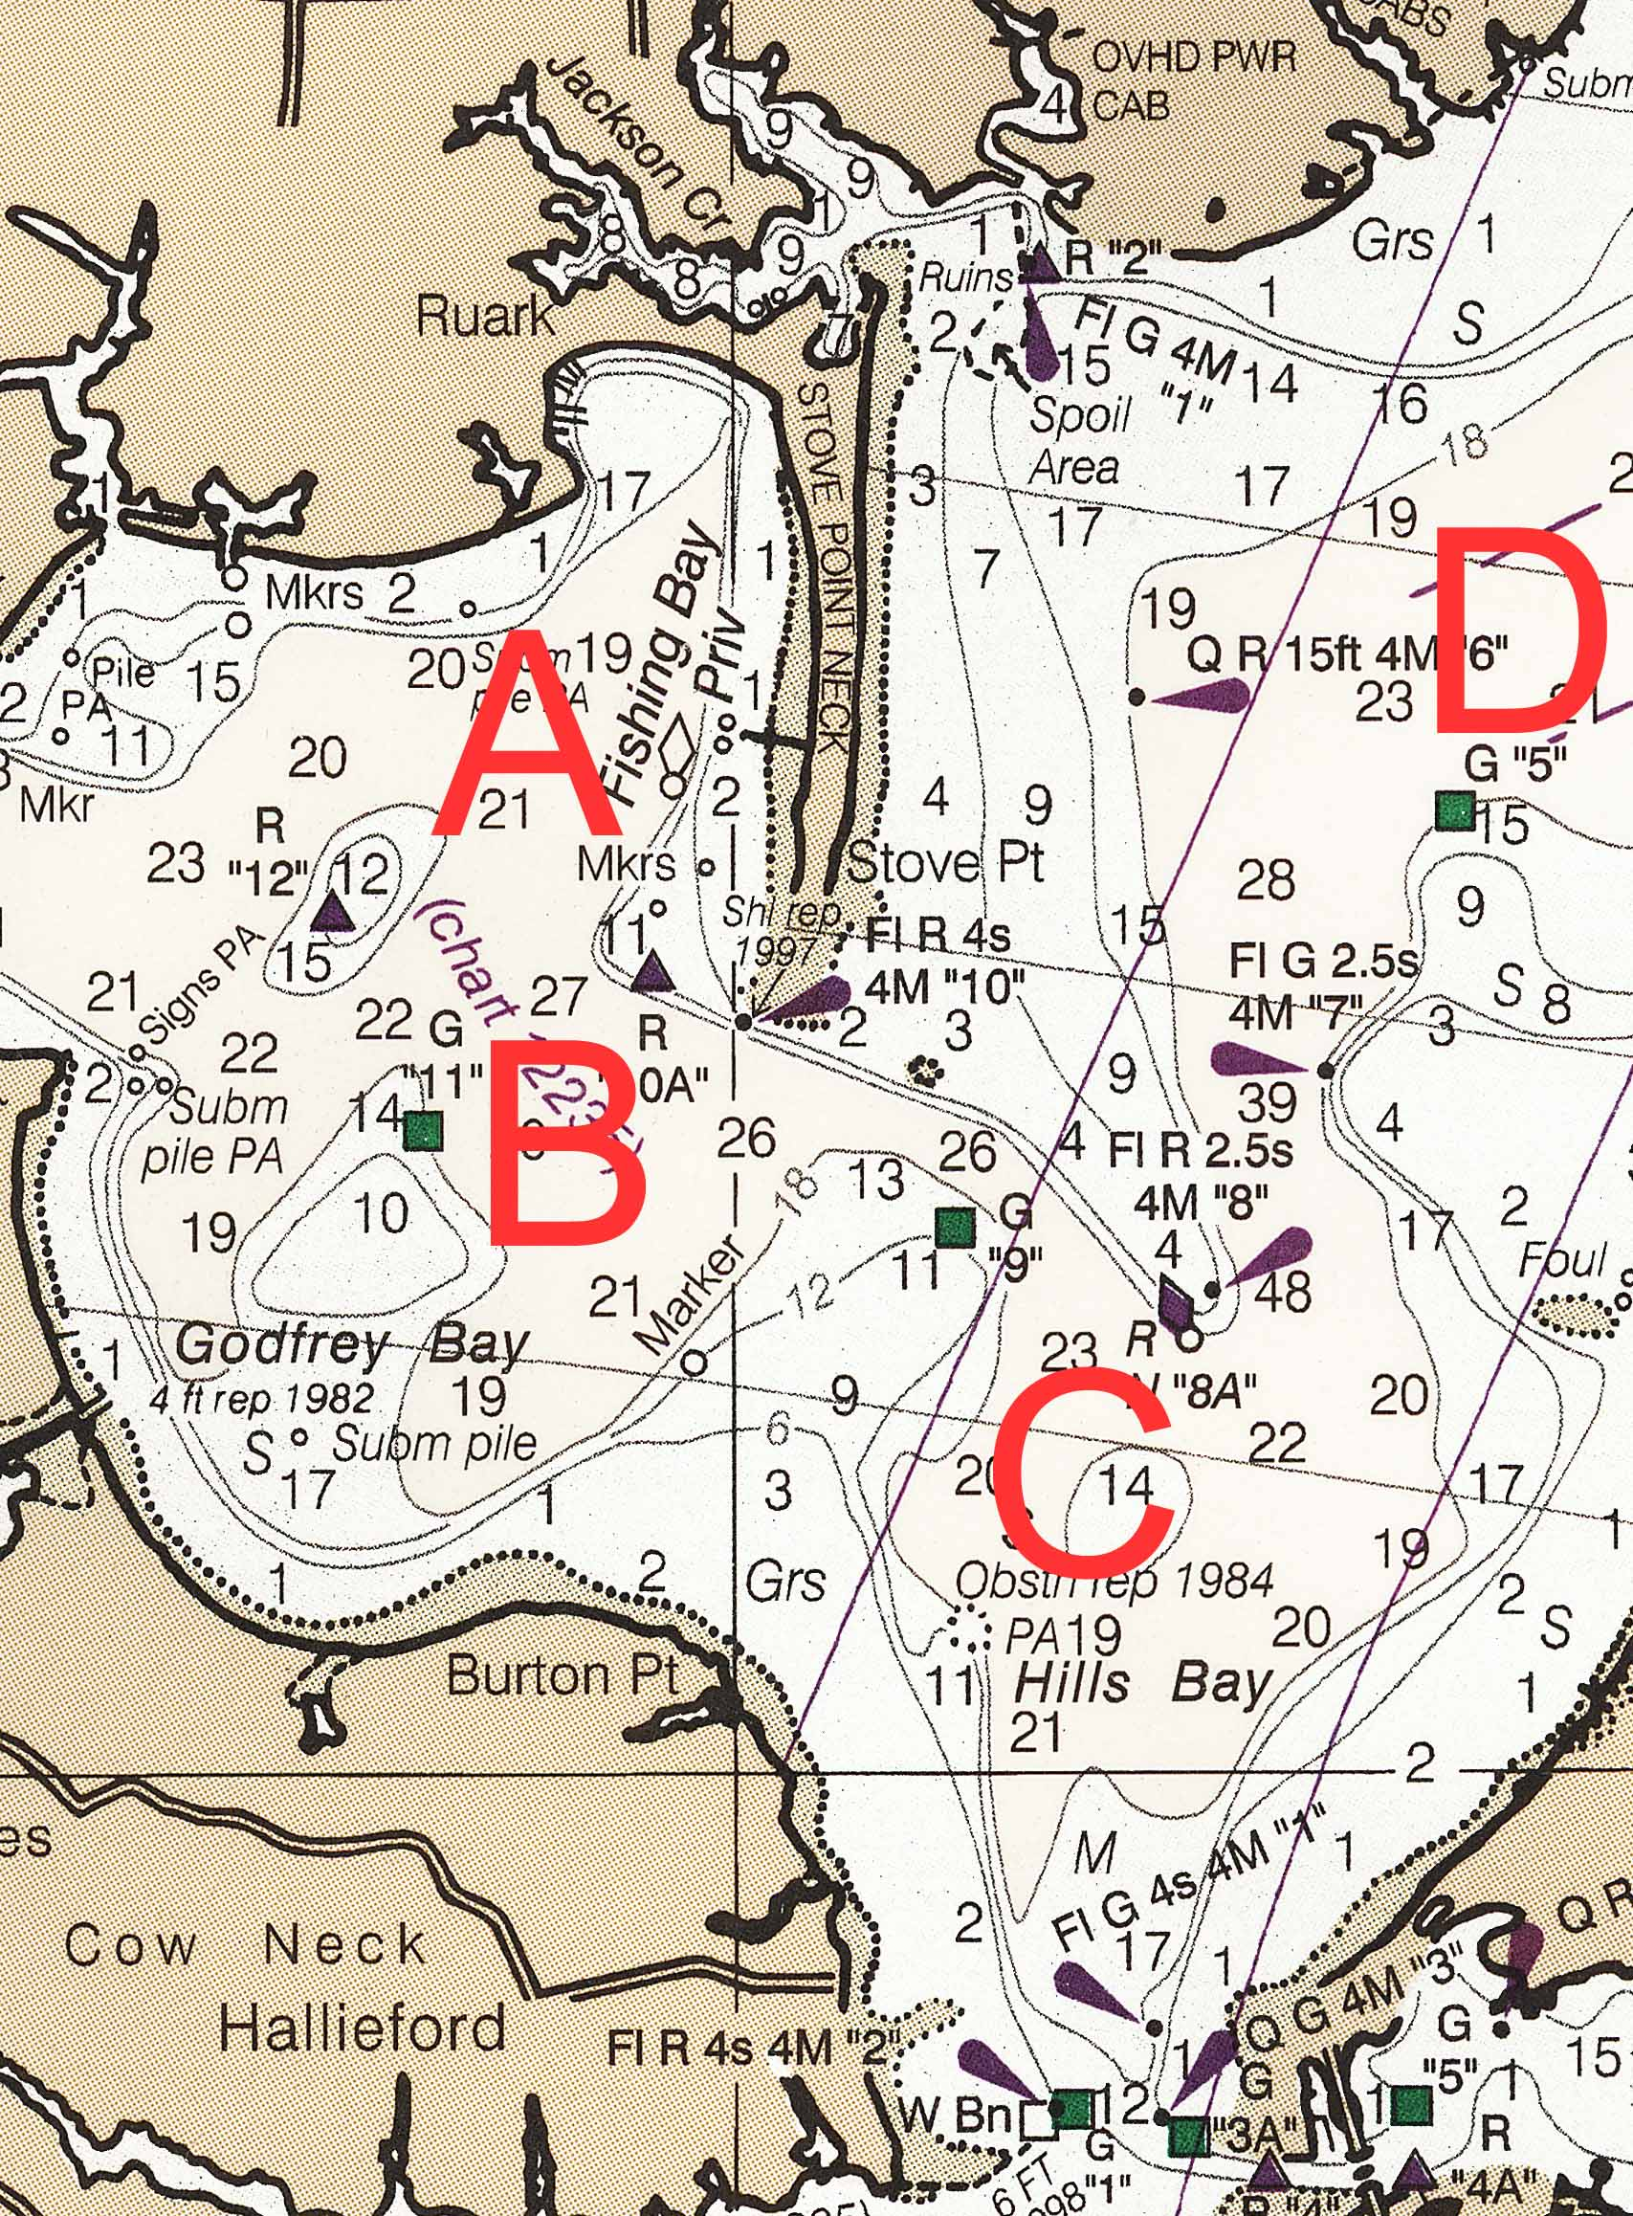
Appendix A: Racing Area Chartlet

Appendix B - COURSE DIAGRAM
S/F
FINISHH
START
F
FINISH

1

1
A

2G
S/F
FINISH
START
COURSE 1: START – 1 - 1A - 2G - FINISH (Upwind)
COURSE 2: START-1 -1A - 2G -1-1A -2G - FINISH (Upwind)
COURSE 3: START-1-1A - 2G – 1 -1A – FINISH (Downwind)

Please Thank and Support our Wonderful Regatta Sponsors






COURSE 1: START – 1 - 1A - 2G - FINISH (Upwind)
COURSE 2: START-1 -1A - 2G -1-1A -2G - FINISH (Upwind)
COURSE 3: START-1-1A - 2G – 1 -1A – FINISH (Downwind)

