LEARN TO CREW AND RACE SAILBOATS
Eight hours of classroom preparation and two days of on-the-water practice for $80
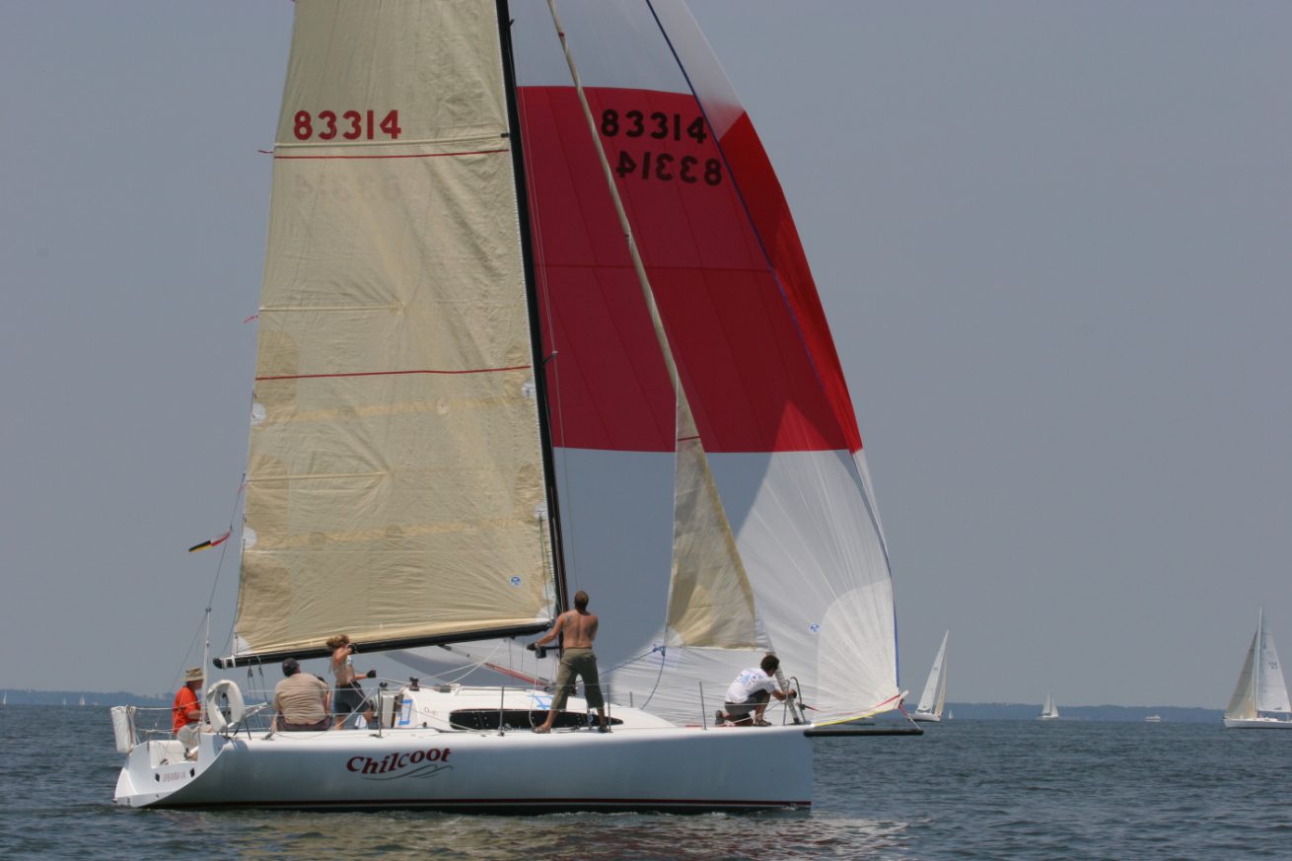
Crew Training is sponsored by Fishing Bay Yacht Club
Classroom sessions in Richmond on March 24, 31, and April 14 (6:30-9:00 pm)
Racing practice in Deltaville on April 18 and May 3
For details and registration, visit www.fbyc.net/Sailing/Crewtraining or contact Jon at jon-fbyc@jdeutsch.com

www.fbyc.net/Sailing/Crewtraining  jon-fbyc@jdeutsch.com | www.fbyc.net/Sailing/Crewtraining  jon-fbyc@jdeutsch.com | www.fbyc.net/Sailing/Crewtraining  jon-fbyc@jdeutsch.com | www.fbyc.net/Sailing/Crewtraining  jon-fbyc@jdeutsch.com | www.fbyc.net/Sailing/Crewtraining  jon-fbyc@jdeutsch.com | www.fbyc.net/Sailing/Crewtraining  jon-fbyc@jdeutsch.com | www.fbyc.net/Sailing/Crewtraining  jon-fbyc@jdeutsch.com | www.fbyc.net/Sailing/Crewtraining  jon-fbyc@jdeutsch.com | www.fbyc.net/Sailing/Crewtraining  jon-fbyc@jdeutsch.com

