Appendix A:
FBYC Letter Designated Course Examples
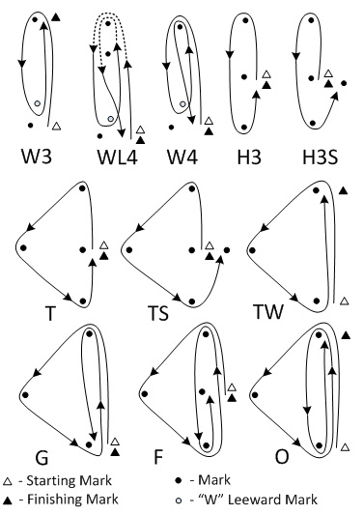A numeral following a “W", "WL", "H", or 'T indicates the number of LEGS for the course.
Appendix B: Whistle Start Sequence
For Opti Green Fleet the starting sequence will consist of the following sound signals made at the indicated times:
Signal Sound Time Before Start
Warning 3 long 3 minutes
Preparatory 2 long 2 minutes
1 long, 3 short 1 minute, 30 seconds
1 long 1 minute
3 short 30 seconds
2 short 20 seconds
1 short 10 seconds
1 short 5 seconds
1 short 4 seconds
1 short 3 seconds
1 short 2 seconds
1 short 1 second
Start 1 long 0
For complete text, included in these SI’s by reference, see Appendix Q, RRS.

Appendix C: Racing Area

FBYC Junior Division Commander - Mark Hayes
Regatta Chairs – Mark Hayes & Michelle Hayes
Opti Green Fleet Race Officer - Doug Bendura
Opti Championship Race Office - Bo Bragg
Laser/420 Race Officer – Ric Klien
Scorers - Paul & Julie Ann Wash


2015 Junior Olympic
Sailing Festival and Chesapeake Bay Open
Sailing Instructions

Schedule of Events

Saturday, June 27, 2014
0900 Registration
1000 Skipper’s meeting
1130 1st Warning Signal
Followed by as many as seven races, as conditions permit.

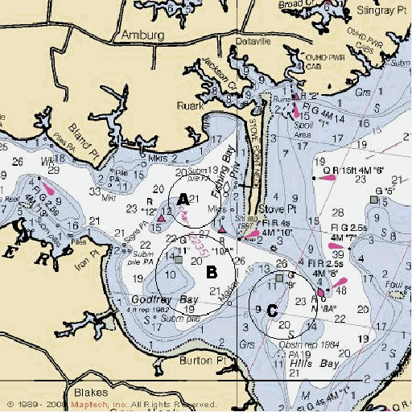
Bag lunches will be distributed on the water.

Cookout to follow racing

Sunday, June 28
1000 1st Warning Signal, followed by as many as five races, as conditions permit.
Races will be followed by awards and light food.

1. Rules
1.1 The Regatta will be governed by these sailing instructions and by the Racing Rules of Sailing (RRS), the prescriptions of US Sailing, the rules of the Class Associations of boats entered in this regatta, except as amended by these sailing instructions.
1.2 For advertising purposes, the Regatta is designated Category A in accordance with ISAF Regulation 20.
1.3 Section 16, Time Limit, amends RRS 35.
1.4 Section 17.3, Protests, amends RRS 60.
2. Entries
2.1 Eligible competitors shall be Junior members of a recognized yacht club or sailing association with an Optimist, Laser, Laser Radial or 420. CBYRA junior age eligibility limits apply.
2.2 Completed entry forms shall be in the hands of the Race Committee by the end of the Skippers’ Meeting.
3. Safety and Environmental Awareness
3.1 A boat shall carry all equipment required by her class rules.
3.2 USCG-approved PFDs shall be worn by each sailor.
3.3 Boats shall check in with the race committee boat at the starting area before their initial race of the day.
3.4 Boats that retire from a race or before racing for the day is over shall notify the race committee as soon as possible.
3.5 A Boat requesting assistance should attempt to signal by
waving an extended arm.
3.6 Boats observed purposefully discharging trash into the water will be subject to sanctions up to and including disqualification from all races.
4. Notices to Competitors
Notices to competitors will be posted on the Official Notice Board located inside the FBYC Clubhouse.
5. Changes to Sailing Instructions
Any change to these sailing instructions will be posted on the Official Notice Board no less than 1 hour before the first warning signal on the day it will take effect.
6. Signals Made Ashore
6.1 Signals made ashore will be displayed on the Committee Boat at the FBYC Dock or on the flagpole on the Fishing Bay Dock.
6.2 Flag AP hoisted with two sound signals means
“The race is postponed.” The warning signal will be made
not less than 30 minutes after AP is lowered (with one sound). This changes RS-Race Signals.
6.3 Flag N hoisted over flag H with three sound signals
means “The races are abandoned.”
6.4 After returning to the dock, the race committee will hoist Flag B with one sound signal, signifying “Protest time has begun.” When lowered, 45 minutes later, with one sound signal, signifying “Protest time has ended.”
7. Schedule of Races
7.1 The Skippers Meeting on Saturday shall be at 1000.
7.2 The first race Warning Signal on Saturday shall be at 1130.
7.3 The Warning Signal for subsequent races shall follow the preceding race. One race will constitute a series and seven races is the maximum to be attempted on Saturday.
7.4 First Warning Signal for Sunday Racing shall be at 1000.
7.5 Subsequent races to follow, to a maximum of five for Sun.
7.6 No races shell be started after 1430 hrs on Sunday.
8. Class Designation
8.1 Fleet flags used in the starting sequence in 12.1 of these SI’s will be designated at the Skipper’s meeting.
8.2 There will be two separate Optimist Course. Optimists
will be divided into Red, White, Blue and Green Fleets, as defined by USODA. Red White and Blue Fleets will start together on one course. The Green Fleet will have a separate course area located closer to the club house.
9. Racing Area
The racing areas will be in the Fishing Bay area and the Piankatank River, as shown in the chart in Appendix C, indicated by circles “A”, “B” and “C” on the chart, and posted prior to the Skipper’s Meeting.
10. The Course
10.1 The diagrams printed in Appendix A show the
courses, the order in which marks are to be passed, and the side on which each mark is to be left.
10.2 For the Optimist fleet, the race committee will declare at the skipper’s meeting whether a gate or single downwind mark will be used for any Optimist course in Appendix A.
10.3 The course for each class will be displayed on the course board near the starboard side of the race committee boat.
10.4 If course W, WL or H is designated, the number following the letter will designate the number of course Legs of the course. Example: “W2” is windward/ leeward, “W3” is windward/leeward/windward, etc. with the finish at the end of the last leg.
10.6 For “W” courses, the Start Line
may be set to leeward of the Leeward Mark of the course. If
this is used, the Leeward Mark will not be a mark of the
course during the first leg of the course and, in the event
of a downwind finish, during the last leg of the course.
11. Marks
11.1 The rounding marks for all classes will be inflatable
marks, the colors of which will be designated at the Skipper’s Meeting of the respective race courses.
11.2 New Marks, as provided in RRS 33, (Changing
Course After the Start) will be inflatable marks of a different color or with an added contrasting color band.
11.3 The starting and finishing marks may be inflatable or
cylindrical marks.
12. The Start
12.1 Either the Five-Minute flag hoist sequence, per Rule 26, RRS, or the three minute whistle start sequence, per Appendix Q, RRS and annotated in Appendix B to these SI’s, may be used.
12.2 The starting line will be between the staff from which
an orange flag is displayed on the RC signal boat and the starting mark. A mark boat may substitute for a starting mark.
12.3 Boats starting more than four (4) minutes after their class start will be scored DNS.
13. Recalls
The Race Committee will attempt to hail OCS boats after the starting signal. Timeliness, lack of a hail, order of hailing or failure to hear a hail shall not be grounds for granting redress.
15. The Finish
15.1 The finishing line will be between a staff displaying an orange flag on a committee boat and the adjacent finishing mark.
15.2 Immediately after downwind finishes, all boats are requested to trim mainsails to display sail numbers to the race committee.
16. Time Limit
16.1 The time limit will be seventy-five (75) minutes from class start to first boat to finish.
16.2 Boats failing to finish within fifteen (15) minutes after the first boat finishes or within the time limit, whichever is later, will be scored “Did Not Finish.” This changes RRS 35. In the interest of time, the Race Committee may elect to score boats that it determines cannot finish within the time limit DNF and start a subsequent race.
17. Protests
17.1 Protests shall be on written forms available at the Protest Desk (in the main club house). Portest forms shall be completed to the Protest Deck within the Protest time limit.
17.2 The Protest Committee will hear protests in approximately the order of receipt and as soon as possible.
17.3 A boat may not protest a boat for an alleged breach of RRS 75.2 (Eligibility) with respect to ISAF Regulation 19, nor for alleged breaches of sailing instructions 3 & 20. This changes Rule 60. The penalty for breaking these instructions may be less than disqualification, at the sole discretion of the protest committee.
18. Scoring
18.1 The Low-Point scoring system, Appendix A,
RRS, will apply.
18.2 If five or more races are sailed, each boat’s worst score will be excluded.
18.3 Red, White and Blue Fleet Optimists will be scored separately by fleet and overall. Green Fleet will be scored separately.
18.4 The event is sanctioned for CBYRA Junior High Point Awards. Scores will be submitted to CBYRA.
19. Awards Awards will be presented as follows:
420 Overall 1st, 420 Girls 1st
Laser Overall 1st - 5th
Laser Girls 1st - 5th
Opti Overall Champion, Opti Girls Overall Champion
Opti Fleets (Red, White and Blue) 1st- 5th
Opti Green Fleet will receive participation mementos.
20. Support Boats
20.1 All support boats are welcome. All support boats are required to notify registration of their intent to be near the course, as well as which boats they are supporting. By registering as a support boat, the operator(s) acknowledge their obligation to: 1) not interfere with any ongoing race; 2) to render aid to any sailors in distress, 3) to monitor the racecourse safety channel, to be designated at the Skipper’s Meeting, and; 4) to set the example in terms of safety and on-the-water decorum, including trash disposal.
20.2 On-the-water coaching for Green Fleet sailors is encouraged, subject to the obligations in 20.1. Race-time coaching is only for sailors in a lower half position in the race being sailed.
20.3 Failure to adhere to these standards could result in sanctions up to and including disqualification of all supported team members from any or all races.

