
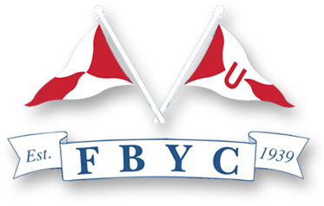

NOTICE OF RACE

Hampton One-Design National Championship

Fishing Bay Yacht Club, Deltaville, Virginia - August 11, 12 & 13 2017
WHERE: Registration and launch facilities at Fishing Bay Yacht Club, Deltaville, Virginia. Races will be sailed in the mouth of the Piankatank River, East or South of Stove Point.
WHEN: Registration and check-in for this regatta will be from 1000-1150 on Friday, August 20. A skipper's
meeting will be held at noon on that day. Six races are scheduled as follows:

Race Day and Date Time
1 Friday, Aug. 11 1400 -- Warning Signal
2 Friday, Aug. 11 Immediately after Race 1

3 Saturday, Aug. 12 1030 -- Warning Signal
4 Saturday, Aug. 12 Immediately after Race 3
5 Saturday, Aug. 12 Immediately after Race 4

6 Sunday, Aug. 13 1030 -- Warning Signal
Make-up Sunday, Aug. 13 Immediately after Race 6, if required

No races will be started after 1500, Sunday, August 13. Four races must be completed to
constitute a series. There will be a throw-out if all six races are completed.

RULES: The regatta will be governed by the Racing Rules of Sailing (RRS), together with the prescriptions of US Sailing, the Hampton One Design class rules and the Sailing Instructions issued at registration.

CLASSES: All Hampton One Design owners are eligible to enter. The Hampton One Design National Executive Committee will make final decisions on eligibility, including waiver of eligibility requirements.

EQUPMENT: Competitors are reminded that the class rules require each boat to carry a paddle, an anchor, 50 feet of 1/4-inch anchor line, and life jackets for the skipper and crew. This equipment must be available for verification by class measurers between 1000 and 1150 Friday morning.

ENTRY FEE: Competitors are encouraged to pre-register; registration materials and instructions available at http://www.hamptononedesign.com. The early registration fee is $290, which includes 3 days of racing, dinner and parties on Friday and Saturday nights for skipper and crew. An additional $25 will be charged if registration is not paid August 5. Pre-registered competitors must check in at the registration table on Friday morning between 1000 and 1150 for Sailing Instructions, equipment forms, and meal tickets.

CONTACTS: Latane & Patricia Montague, (703) 626-3543 (cell), (202) 637-6567 (w) or Latane.Montague@hoganlovells.com

