Notice to FBYC Boat Operators

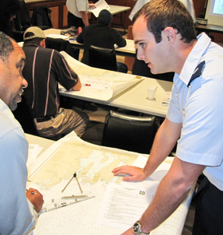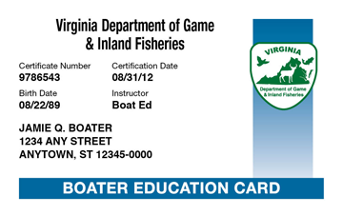

Event: Virginia Boater Card Course
Location: Fishing Bay Yacht Club, Main Clubhouse, Second Floor
Time: 8:30 am until completion of examination
Date: Saturday, March 22, 2014
Registration: www.fbyc.net
This year’s course will again be held at the clubhouse and will be conducted by Flotilla 66 of the United States Coast Guard Auxiliary. As of July 31st of 2014, the Commonwealth of Virginia will mandate that in order to operate a vessel powered by a motor of 10 HP or greater, all operators 45 years of age and younger will be required to have taken and passed this course, or similar boating safety training. Registration will be limited to 50 people, so sign up early. Coffee and Danish plus a light lunch will be served. Total cost: $10.00. Contact Gordon and Jane Cutler at gbcutler@gmail.com or call (804) 776-7630.

